STANDARD OPERATING PROCEDURE
Title: Mouse Plasma Assay Validation on Agilent 6495 or 6490.
Version #: 1 | Author: UVic GBC Proteomics Centre
Date: 09/08/2017

Purpose

The purpose of this document is to describe the characterization of a set of assays including response curve and assay repeatability (reverse curve version).

Scope

This procedure covers general preparation and running of samples for the response curve and repeatability experiments.

Responsibilities
It is the responsibility of person(s) performing this procedure to be familiar with laboratory safety procedures. The interpretation of results must be done by a person trained in the procedure and familiar with such interpretation.

Equipment
- Pipettes
- 37˚C dry air incubator
- Vortex mixer
- Microcentrifuge
- Balance
- Positive Pressure Vacuum manifold
- 1L graduated cylinder
- Agilent 6490 or 6495 QQQ
- Skyline software

Materials
  - Worthington Trypsin-TPCK treated (Worthington, LS003744)
  - Urea (Sigma, U0631)
  - DL-Dithiothreitol, DTT (Sigma, 43815)
  - Iodoacetamide, IAM (Sigma, I1149)
  - Trizma base (Sigma, T6791)
  - Water, LC-MS grade (Fisher, W64)
  - Acetonitrile, LC-MS grade (Sigma, 34967)
  - Methanol, LC-MS grade (Sigma, 34966)
  - Formic Acid, LC-MS grade (Sigma, 56302)
  - 1.5mL Eppendorf Protein LoBind Tube (Eppendorf, 022431081)
  - Falcon 15mL conical centrifuge tubes (Corning, 352096)
  - Falcon 50mL conical centrifuge tubes (Corning, 352070)
  - Axygen 1.1ml deep well plate (VWR, 47734-788)
  - Axygen silicone mat for 1.1ml plate (VWR, 10011-126)
  - Oasis HLB µElution Plate, 30µm (Waters, 186001828BA)
  - AlumaSeal II foil seals (Fisher, 361006023)
  - Eppendorf twin tec PCR Plate 96 (Eppendorf, 951020401)
  - Axygen silicone mat for Eppendorf PCR plate (Fisher, AM-96-PCR-RD)
  - Mouse plasma
  - Heavy stable isotope-labeled standard (SIS) peptides and matched light versions were synthesized and purified by HPLC. Heavy peptides incorporated a fully atom labeled 13C and 15N isotope at the C-terminal lysine (K) or arginine (R) position of each (tryptic) peptide, resulting in a mass shift of +8 or +10 Da, respectively. Peptides were quantified by amino acid analysis and aliquots were stored in 30% acetonitrile, 0.1% formic acid at -80˚C until use.

Solutions
- 1M Tris, pH 8.0. May be made in advance and stored at 4˚C:
  - Add 12.12g solid Trizma base to a 250mL beaker.
  - Add 50mL LC-MS water and mix until dissolved.
  - Adjust pH to 8.0 with concentrated HCl (12M).
  - Transfer solution to 100mL graduated cylinder and bring volume to 100mL with LC-MS water.
- 9M Urea, 300mM Tris, pH 8.0. Must be made fresh daily:
  - Add 5.4g Urea to a 50mL Falcon tube.
  - Add 3mL LC-MS water and 3mL 1M Tris, pH 8.0 and mix until dissolved.
  - Measure pH and bring to 8.0 if necessary.
  - Bring volume to 10mL with LC-MS water.
- 9M Urea, 300mM Tris, pH 8.0, 20mM DTT. Must be made fresh daily:
  - Dissolve 15.4mg DTT in 200µL 9M Urea, 300mM Tris, pH 8.0 solution (above).
  - Add 40µL to 960µL 9M Urea, 300mM Tris, pH 8.0 (above) in a 15mL Falcon tube.
  - Mix well.
- 500mM Iodoacetamide (IAM). Prepare immediately before use and protect from light:
  - Dissolve 56mg IAM in 605μL LC-MS water.
  - Mix well.
- 100mM Tris, pH 8.0:
  - 1 part 1M Tris, pH 8.0 (above).
  - 9 parts LC-MS water.
- 1mg/mL Worthington TPCK- Trypsin. Prepare immediately before use:
  - Dissolve 2mg trypsin in 2mL 100mM Tris.
- 60% Acetonitrile, 0.1% Formic Acid:
  - Add 6mL Acetonitrile to 3.990mL LC-MS water.
  - Add 10µL Formic Acid.
- 30% Acetonitrile, 0.1% Formic Acid:
  - Add 3mL Acetonitrile to 6.990mL LC-MS water.
  - Add 10µL Formic Acid.
- 0.1% Formic Acid:
  - Add 10µL Formic Acid to 9.990mL LC-MS water.

Matrix Digestion (Experiment 1 & 2)

Tryptic Digestion of Representative Matrix
- The digested matrix is used for Assay Validation Experiment 1 (Response Curve) and Assay Validation Experiment 2 (Repeatability). Digest replicates may be prepared simultaneously and stored at -80ºC until needed: Prepare 10 replicates (6 for Assay Validation Experiment 1 and 4 for Assay Validation Experiment 2).
- Add 50µL 9M Urea, 300mM Tris, pH 8.0, 20mM DTT to each respective well of a 1.1ml deep well plate.
- Add 25µL of undiluted plasma. Cover with silicone mat.
- Denature and reduce at 37˚C for 30min.
- Add 6.5µL 500mM IAM. Cover with silicone mat.
- Alkylate at room temperature for 30min in the dark.
- Add 736µL 100mM Tris, pH 8.0 to decrease urea concentration to <0.55M.
- Add 62.5µL of 1µg/µL Worthington Trypsin for a 20:1 substrate:enzyme ratio. For the purposes of this protocol, undiluted plasma is assumed to have a protein concentration of 50µg/µL. Cover with silicone mat.
- Incubate at 37˚C for 18hrs.
- Add 150μL of 10% Formic Acid to quench digestion.
- Total volume post digest = 1030µL, plasma protein concentration = 1.21µg/µL.
- Store digests at -80˚C until required.

Experiment 1- Response Curves

Heavy SIS spike preparation
- Prepare a 10pmol/µL equimolar mix of SIS peptides in 30% Acetonitrile, 0.1% Formic Acid.
- Prepare serially diluted SIS peptide mix using 1.5mL Protein LoBind Eppendorf Tubes (table below).
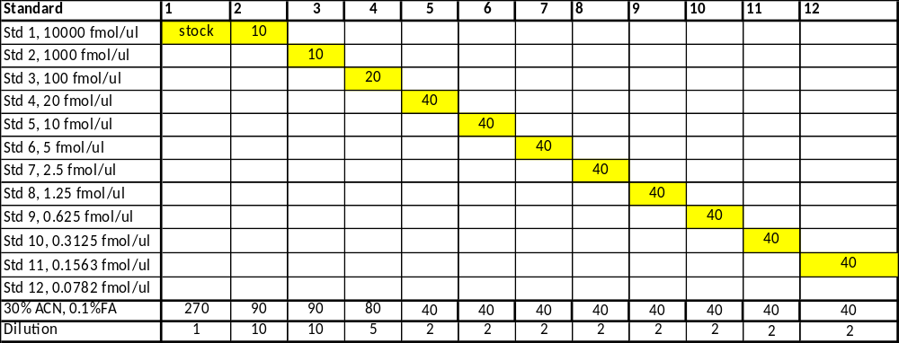
- Explanation of Standards (table below). Note: Less than 12 standards may be prepared depending on the target range of the response curve.

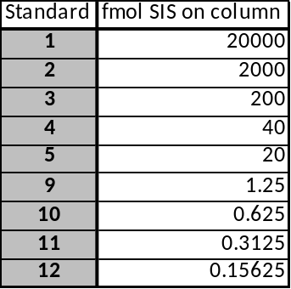

Light spike preparation
- Prepare a 10pmol/µL equimolar mix of Light peptides in 30% Acetonitrile, 0.1% Formic Acid.
- Dilute stock Light peptide mix to 100fmol/µL in 30% Acetonitrile, 0.1% Formic Acid using a 1.5mL Protein LoBind Eppendorf tube.
Standard Curve preparation
- To 12 x 1.5mL Protein LoBind Eppendorf tubes add:
  - 82.4µL plasma digest
  - 10µL of 100fmol/µL Light peptide mix
  - 10µL of level specific SIS peptide mix
  - 497.6µL 0.1% Formic Acid

Double blank (prepare 3 replicates)
- To a 1.5mL Protein LoBind Eppendorf tubes add:
- 82.4µL plasma digest
- 20µL 30% Acetonitrile, 0.1% Formic Acid
- 497.6µL 0.1% Formic Acid

Optional: SIS + Matrix blank preparation (to estimate endogenous concentration)
- To a 1.5mL Protein LoBind Eppendorf tube:
- 82.4µL plasma digest
- 10µL of 100fmol/µL SIS peptide mix
- 10µL of 30% Acetonitrile, 0.1% Formic Acid
- 497.6µL 0.1% Formic Acid

Desalting and Concentrating Samples Offline by Solid Phase Extraction
- When operating the Positive Pressure Manifold, apply enough pressure to maintain a flow rate of 1mL/min, do not exceed 5 psi. During elution, choose the lowest possible psi to minimize sample loss due to splashing.
- Perform SPE using an Oasis HLB µElution Plate. To all appropriate wells:
  - Condition with 600µL of Methanol.
  - Equilibrate with 600µL of 0.1% Formic Acid.
  - Add 600μL sample to wells:
  - Wash with 3 x 600µL of LC-MS water.
  - Elute peptides with 70µL 60% Acetonitrile, 0.1% Formic Acid into a 96 well Eppendorf twin tec PCR plate.
  - Seal using AlumaSeal II foil.
- Freeze eluates using liquid nitrogen, and poke a hole in the seal over each well.
- Lyophilize samples to dryness overnight.
- Seal using AlumaSeal II foil and pellet lyophilate by centrifugation.
- Samples can be stored lyophilized at -80°C until ready for MRM analysis.
Reconstituting Samples (To be performed just prior to LC/MRM-MS analysis)
- Reconstitute desalted and dried digests with 100µL of 0.1% Formic Acid to each sample (1μg/μL plasma digest).
- Vortex sample, spin down, remove AlumaSeal II foil, and cover with silicon mat for LC/MRM-MS analysis.
Experiment 2- Mini-Validation of Repeatability

Heavy SIS and Light spike preparation
- Prepare both a SIS and Light mix 500x the Lowest point on curve (LPOC) of each peptide per µL of 30% Acetonitrile, 0.1% Formic Acid, calculated from Experiment 1 data. (eg. if the LPOC of your peptide was 200fmol, the concentration of the mix will be 100pmol/µL). The LPOC for each peptide is obtained from Experiment 1 results.
- Dilute stock Light peptide mix to 100x LPOC/µL in 30% Acetonitrile, 0.1% Formic Acid using a 1.5mL Protein LoBind Eppendorf tube. Dilue the Heavy SIS peptide mix to 250x LPOC/µL in 30% Acetonitrile, 0.1% Formic Acid using a 1.5mL Protein LoBind Eppendorf tube.
- Prepare serially diluted SIS peptide mix in 30% Acetonitrile, 0.1% Formic Acid in 1.5mL Protein LoBind Eppendorf tubes (table below):

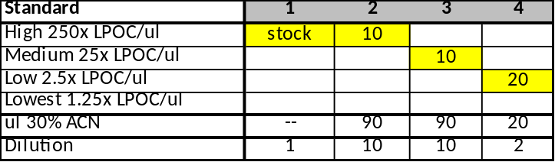

- Explanation of the levels (table below). Notes: Standard 3 or 4 may be omitted according to experiment. LPOC concentrations are determined from Experiment 1 data.

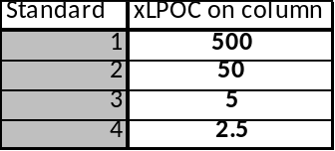
Sample preparation
- Prepare independently 5x (i.e., 5 different calendar days):
- To 4 x 1.5mL Protein LoBind Eppendorf tubes add:
- 82.4µL plasma digest
- 10µL of 100x LPOC Light peptide mix
- 10µL of level specific SIS peptide mix
- 497.6µL 0.1% Formic Acid

Desalting and Concentrating Samples Offline by Solid Phase Extraction
- When operating the Positive Pressure Manifold, apply enough pressure to maintain a flow rate of 1mL/min, do not exceed 5 psi. During elution, choose the lowest possible psi to minimize sample loss due to splashing.
- Perform SPE using an Oasis HLB µElution Plate. To all appropriate wells:
  - Condition with 600µL of Methanol.
  - Equilibrate with 600µL of 0.1% Formic Acid.
  - Add 600µL sample.
  - Wash with 3 x 600µL of LC-MS water.
  - Elute peptides with 70μL 60% Acetonitrile, 0.1% Formic Acid into a 96 well Eppendorf twin tec PCR plate.
  - Seal using AlumaSeal II foil.
- Freeze eluates using liquid nitrogen, and poke a hole in the seal over each well.
- Lyophilize samples to dryness overnight.
- Seal using AlumaSeal II foil and pellet lyophilate by centrifugation.
- Samples can be stored lyophilized at -80°C until ready for SRM analysis.

Reconstituting Samples (To be performed just prior to LC/MRM-MS analysis)
- Reconstitute dried and desalted spiked digests with 100µL of 0.1% Formic Acid to each sample (1μg/μL plasma digest).
- Vortex sample, spin down, remove AlumaSeal II foil, and cover with silicon mat for LC/SRM-MS analysis.
LC and MS Setup (Experiment 1 & 2)

LC Setup and Parameters:
- Buffer A: 100% LC-MS grade water + 0.1%FA
- Buffer B: 100% LC-MS grade Acetonitrile + 0.1%FA
- Flowrate: 0.4mL/min
- Column temp: 50˚C
- Gradient:
Time (min) | % Buffer A | % Buffer B
0 | 98 | 2
2 | 93 | 7
50 | 70 | 30
53 | 55 | 45
53.5 | 20 | 80
55.5 | 20 | 80
56 | 98 | 2
+ 4min post time to equilibrate column

Agilent 6490/6495 MRM Parameters:
- Transitions:
    - Monitor 3-5 transitions for each light and SIS peptide.
    - MS1 and MS2 Resolution: unit
    - Fragmentor: 380V
    - Cell Accelerator Voltage: 5
- Dynamic MRM Parameters:
    - Cycle time: <900msec
    - Min Dwell: ≥9msec
- Source parameters:
    - Gas Temp: 150˚C
    - Gas flow: 15L/min
    - Nebulizer: 30psi
    - Sheath Gas Temp: 250˚C
    - Sheath Gas Flow: 11L/min
    - Positive Capillary: 3500V
    - Nozzle Voltage: 300V
Naming of Data Files:
- Experiment 1:
  - Curve levels should be named Std1 to Std12, with Std12 being the least concentrated sample and Std1 being the most concentrated sample. Blanks should be named Blank (for blanks run at the beginning of the experiment) and CarryoverBlank (for blanks run following the highest standard of the response curve).
  - Injection replicates should be named R01 to R03.
  - Example: Date_Project_AssayVal_Exp1_Std1_R01
- Experiment 2:
  - Each level should be named 2.5x, 5x, 50x, or 500x, respectively.
  - Level names correspond to level numbers 4,3,2, and 1, respectively.
  - Injection replicates should be named R01 to R03.
  - Injections should be dated.
  - Example: Date_Project_5x_2_R01
Sample injection:
- Injection volume will be 20µL to load 20ug total digest on column.
- Experiment 1:
  - A double blank will be injected 3x prior to the curves to estimate noise.
  - Inject samples in singlicate from low concentration to high concentration.
  - Two double blanks will be injected between curves to assess carryover.
  - Three complete replicates of the curve and carryover blanks are injected.
- Experiment 2:
  - Inject samples from low to high concentration.
  - Each of the 2.5x, 5x, 50x, or 500x samples will be injected in triplicate on each of 5 different calendar days. Triplicate injections are performed in sets (eg. 2.5x-500x R01, 2.5x-500x R02, and 2.5x-500xR03).
  - Two buffer blanks will be injected between the 500x and 2.5x samples.

Data Analysis (Experiment 1 & 2)

Quantitation of Data using Skyline:
- Analysis is performed using Skyline
- Inspect and correct integration if necessary
- Save and upload to Panorama

Referenced Documents

