
CPTAC STANDARD OPERATING PROCEDURE

Title: Preparation of Standard Peptide Solutions for a “Mini-validation” (CPTAC Assay Experiment 2)

SOP: WU-SOP-EXP2  Version: 1 | Author: Townsend Lab
Date: March, 2021

Purpose
The purpose of this document is to describe the preparation of samples to perform Experiment 2. The design of Experiment 2 is described at the CPTAC Assay Portal (https://assays.cancer.gov/guidance-document/).
Scope
The preparation of sample with concentrations near (1.5-3) the LLOQ (LOW), 50-100 times the LLOQ (MEDIUM), and > 100 times the LLOQ (HIGH) is described for LC-MS analysis (WU-SOP-LC3). The preparation of admixture solutions of high purity synthetic natural abundance (L, light) and stable isotope-labeled (H, heavy) peptides at these three concentrations of L peptide is detailed. The preparation of sufficient material to perform replicate LC-MS experiments (n=3) at each level in five batches over ~ 15 days to assess the reproducibility and repeatability of peptide measurements in the complex matrix described in WU-SOP-COMP-PEP-MATRIX. Experiment 2 is designed to resembles an actual experiment.
The preparation of the samples from the vendor vials and the dilution scheme are described in WU-SOP-EXP1.
The peptide concentrations for the LOW, MEDIUM and HIGH are determined from the results of Experiment 1.

QC Standard | Final Concentration (fmol/µL)
QCL | 2
QCM | 100
QCH | 200

Page 1 of 6

Responsibilities
It is the responsibility of person(s) performing this procedure to be familiar with laboratory safety procedures and relevant good practice procedures of laboratory biochemistry and analytical chemistry. The interpretation of results must be performed by person(s) trained in the procedure and trained in the interpretation of LC-MS results from stable isotope dilution mass spectrometric experiments and be familiar with the acceptance criteria described for this experiment (https://assays.cancer.gov/guidance-document/).

Materials

Reagents
- Synthetic high purity stable isotope labeled and natural abundance peptides, New England Peptide. The peptides were supplied in vials containing 100 nmol of each peptide.
- Primary stock solution of the heavy (HPS) or light (LPS) peptide; prepared by direct dilution and transfer from the vendor vial, (20,000 fmol/µL)
- Secondary stock of the heavy (HSS400) or light (LSS400) primary peptide stock solution. ( 400 fmol/µL)
- Purified tryptic peptides from bovine serum albumin (WU-SOSIMPEP-MATRIX)
- Purified tryptic peptides from a SUM-159 cell line (WU-SOP-COMP-PEP-MATRIX)
- Water, LC-MS grade (JT Baker, cat. no. 4218-03- 4L)
- Acetonitrile (MeCN), >99.9 % (vol/vol) LC-MS grade (JT Baker, cat. no. 9829-03- 4L)
- Formic Acid (FA), 98% (vol/vol), 250 mL (Honeywell Fluka, cat. no. 94318-250mL)

Equipment
- Microcentrifuge (Eppendorf, cat. no. 5415D)
- Sorval centrifuge RC6Plus; rotor: HB-6 (Thermo Fisher Scientific, cat. nos. NC0386709 and 11-860)
- Pipet-lite XLS, P20, P200, P1000 (Rainin, cat. nos. 17014392, 17014391, 17014382)
- MAXYmum™ recovery tips: P1000 (Axygen, cat. no. T-1000-C-L-R)
- MAXYmum™ recovery tips: P200 (Axygen, cat. no. T-200-C-L-STK)
- MAXYmum™ recovery tips: P20 (Axygen, cat. no. T-300-L-R)
- KIMAX Volumetric glassware (2, 5, 50, 100 mL flasks) (Kimble cat. nos. 28014-2, 28014-5, 92812G50, 92812G100)
rinse 3x with water, 3 times with 70% (vol/vol) MeCN, 1% FA (vol/vol), 5 times with water
- 500 µL Screwcap microtubes (Sarstedt, cat. no. 72.730.009)
- Screw caps (Sarstedt, cat. no. 65.716.001, 65.716.002, 65.716.005)
- Autosampler vials (Sun-Sri, cat. no. 200 046)
- Autosampler vial caps (Sun-Sri, cat. no. 501-390

Reagent setup

Diluents and Purified BSA Tryptic Peptide Solutions
The solutions for preparing the blanks and LOW, MEDIUM and HIGH standards are described in the WU-SOP-EXP1 and summarized in Table I.

Page 2 of 6
Table I Diluents and Standard Tryptic Peptide “Carrier” Solutions
Solution | Solvents | Peptide Concentration (ng/µL)
FA-1 | FA (1%) (vol/vol) | 0
MeCN/FA-30 | MeCN/FA (30%/1%) (vol/vol) | 0
BSA peptides | MeCN/FA (30%/1%) (vol/vol) | 100

MeCN/FA (30 %/1 %) (vol/vol) (MeCN/FA-30)
Add 50 mL of water to a 100 mL volumetric flask that has been labeled, initialed, and dated. Pipette 1 mL of FA into the flask. Add 30 mL of MeCN. Q.S. with water. The solution is stored sealed at RT for less than one month.

FA (1 %) (vol/vol) (FA-1)
Add 5 mL of water to a 10 mL volumetric flaks that has been labeled, initialed, and dated. Pipette 100 µL of FA into the flask. Q.S with water. The solution is stored sealed at RT for less than one month.

BSA peptides (100 ng/µL) in MeCN/FA (30 %/1 %) (vol/vol)
Transfer 5 mg BSA tryptic digest aliquot to 50 mL volumetric flask. Q.S to the mark with MeCN /FA-30

Stock H/L Admixtures for LOW, MEDIUM and HIGH Standard Solutions.
Remove an aliquot of the HPS, LSS-400 and HSS-400 stock peptide solutions (Table II) from the freezer and thaw on ice.
Transfer ~1 mL of the BSA digest diluent into 2 ml volumetric flasks labeled as shown in Table II.
Table II. Primary and Secondary Peptide Stock Solutions for the Preparation of the LOW, MEDIUM and HIGH Primary and Secondary Stock Solutions1
Solution | Component | Diluent | Concentration (fmol/µL)
Peptide Stock Solutions
LPS | Heavy (H) or Light (L) Primary Stock | BSA peptides | 20,000
HSS-400 LSS-400 | Heavy (H) or Light (L) Secondary Stock | BSA digest | 400
Pipette the indicated volumes from either a H primary or secondary stock solution and a L secondary stock solution to prepare the three varying concentrations of

Page 3 of 6

heavy peptides and a constant quantity of light peptides (Table III).
Q.S. to 2 mL with BSA tryptic peptide diluent.
Dispense as aliquots (55 µL) into 500 µL microtubes and freeze at -80 °C.

1The preparation of these solutions is described in WU-SOP-EXP-1-01
Table III. Volumes and Reagents for Preparation of Concentrated LOW, MEDIUM and HIGH Stock Solutions (10X)
QC Stock | LIGHT  Stock (fmol/µL) | LIGHT  Stock (µL) | HSS - 400(µL) | MeCN/FA-30 (µL) | Final Volume  (µL) | Light Concentration  (fmol/(µL)
HIGH | LPS | 20 | 125 | 1275* | 2000 | 200
MEDIUM | LPS | 10 | 125 | 1575* | 2000 | 100
LOW | LSS-400 | 10 | 125 | 1865 | 2000 | 2

* There are 3 primary stock solutions for this panel

Procedure

Preparation of Standard Samples for LC-MS Repeatability Study

- Remove an aliquot for each of the three H/L admixtures and a vial of the lyophilized peptides from the cell lysae digest (WU-SOP-COMP-PEP-MATRIX) from the freezer and thaw on ice.
- Add 100 µL of MeCN/FA-30 to the matrix vial; vortex for ~30 sec
- Pipette 20 µg of cell digest matrix into all autosampler vials.
- Pipette 20 µL of the respective concentrated stock solution into the designated autosampler vial as shown in Table IV.
- Speedvac to dryness.
- Add 50 µL of FA-1. Vortex each autosampler vial (~ 45 sec) and centrifuge in Sorval at 8,000 rpm for 20 min.
- Place on autosampler tray at 4 °C for LC-MS analysis using WU-SOP-LC2-01 and WU-SOP-MS4-01.
Table IV. Volumes and Reagents used for Preparation of Standards for LC-MS
Standard | Diluent (FA-1) (µL) | Stock (µL) | Cell lysate matrix spike solution (µg) | Final volume | Final (fmol/µL)
HIGH | 50 | 20 | 20 | 50 | 80
MEDIUM | 50 | 20 | 20 | 50 | 40
LOW | 50 | 20 | 20 | 50 | 0.8

Page 4 of 6

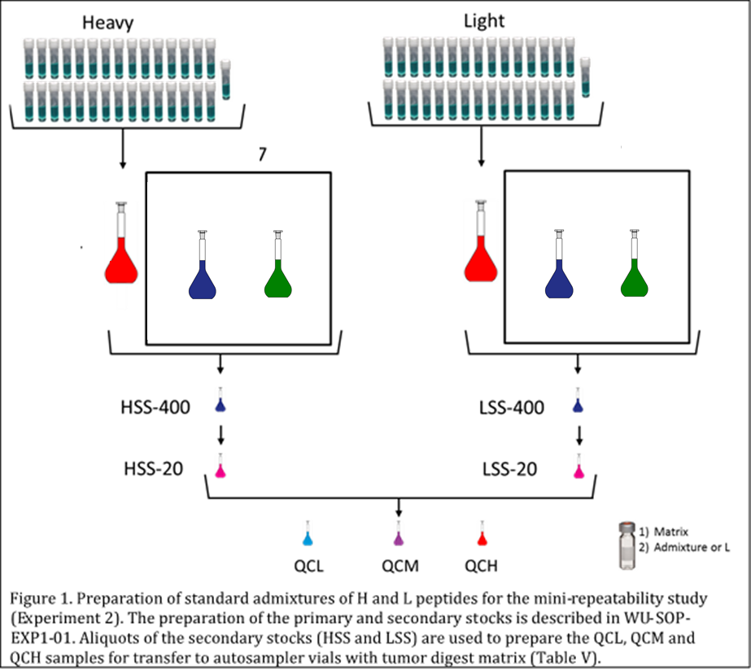

Table V. Example Sample Queue for LC-MS Analysis of LOW (QCL), MEDIUM (QCM) and
HIGH (QCH) for Repeatability Study
BLOCK 1 |  | BLOCK 2 |  | BLOCK 3 |  | BLOCK4 |  | BLOCK5
Sample | Runtime  (hr) | Sample | Runtime  (hr) | Sample | Runtime  (hr) | Sample | Runtime  (hr) | Sample | Runtime  (hr)
PRTC | 1 | PRTC | 1 | PRTC | 1 | PRTC | 1 | PRTC | 1
QCL | 2 | QCH | 2 | QCH | 2 | QCL | 2 | QCL | 2
QCH | 2 | QCM | 2 | QCL | 2 | QCH | 2 | QCH | 2
QCL | 2 | QCL | 2 | QCH | 2 | QCM | 2 | QCM | 2
QCL | 2 | QCM | 2 | QCM | 2 | QCM | 2 | QCH | 2
QCM | 2 | QCL | 2 | QCM | 2 | QCL | 2 | QCM | 2
QCM | 2 | QCH | 2 | QCM | 2 | QCL | 2 | QCH | 2
QCH | 2 | QCL | 2 | QCL | 2 | QCH | 2 | QCL | 2
QCH | 2 | QCH | 2 | QCH | 2 | QCM | 2 | QCM | 2
QCM | 2 | QCM | 2 | QCL | 2 | QCH | 2 | QCL | 2
Runtime (days): 10.7
Page 5 of 6

Referenced Documents
WU-SOP-EXP1- “Preparation of Standard Peptide Samples for the Generation Reverse Response Curves-Experiment 1”
WU-SOP-CD1-01- Preparation of Peptides from Tumor Lysates
WU-SOP-LC3, “nano-Liquid Chromatography for Experiment 1 and 2”
WU-SOP-MS3, “Optimizing Mass Spectrometer Performance for Experiments 1 and 2 on the Q-Exactive™ system”
WU-SOP-MS4, “Mass Spectrometry Using Parallel Reaction Monitoring for Experiments 1 and 2 on the Q-Exactive™ system”

List of Abbreviations
MeCN, acetonitrile
FA, formic acid
BSA, Bovine Serum Albumin
LC-MS, nano-LC interfaced to a high-resolution Quadrupole-Orbitrap Mass Spectrometer as described in WU-SOP-LC2-01 and WU-SOP-M3-01
H or heavy, stable isotopically labeled synthetic peptide
L or light, natural abundance synthetic peptide
Q.S., quantum satis
Min, minutes
Sec, seconds
QCL, sample with 1.5-3.0 x the LLOQ of the set of peptides described in WU-SOP- EXP1-02
HPS, primary stock solution of the heavy peptide; prepared by direct dilution and transfer from the vendor
LPS, primary stock solution of the light peptide; prepared by direct dilution and transfer from the vendor vials.
HSS, secondary stocks of the heavy primary peptide stock solution.
LSS, secondary stocks of the light primary peptide stock solution.

Page 6 of 6

