CPTAC STANDARD OPERATING PROCEDURE
Title: Preparation of Protein Lysates from Tissue Culture Cell Pellets
SOP: WU-SOP-CL
Version: 1 | Authors: Townsend Lab
Date: March, 2021


Purpose
The purpose of this document is to describe the preparation of protein lysates from snap frozen cell pellets in a denaturing buffer.

Scope
This procedure is used to make a lysates from cell lines that are used for the preparation of purified tryptic peptides as a matrix for the development of assays described at the Clinical Proteomics Tumor Analysis Consortium Assay Portal (https://proteomics.cancer.gov/assay-portal)(WU-SOP-COMP-MATRIX).

Responsibilities
It is the responsibility of person(s) performing this procedure to be familiar with laboratory safety procedures and relevant good practice procedures of laboratory biochemistry and analytical chemistry.

Materials

Reagents
- Urea (Millipore Sigma, cat. no. U4884)
- Ethylenediaminetetraacetic acid (EDTA) (Millipore Sigma, cat. no. E1644)
- Phenylmethylsulfonyl fluoride (PMSF) (ThermoFisher Scientific, cat. no. 36978)
- Phosphatase Inhibitor Cocktail 2 (Millipore Sigma, cat. no. P5726)
- Phosphatase Inhibitor Cocktail 3 (Millipore Sigma, cat. no. P0044)
- Sodium Chloride (NaCl) (Thermo Fisher Scientific, cat. no. S271)
- tris(hydroxymethyl)aminomethane-Hydrochloride (Tris Base) (Thermo Fisher Scientific, cat. no. BP152-1)

- Aprotinin (Millipore Sigma, cat. no. A6103)
- Leupeptin (Roche, cat. no. 11017101001)
- Sodium Fluoride (NaF) (Millipore Sigma, cat. no. S7920)
- Water (18.2 MΩ × cm at 25 °C) (Millipore)
- Ethanol (EtOH) (Millipore Sigma, cat. no. 270741)
- Hydrochloric Acid (HCl) (Fisher, cat. no. A144S-500)
- BCA Protein assay kit (BCA) (Pierce, cat. no. 23225)
- Dry ice
- Ice

Equipment
- Focused Acoustics Sonication System (Covaris, cat. no. S220X)
- S220X Chiller (Covaris, cat. no. 510042)
- Micro-centrifuge (Eppendorf, cat. no. 5424)
- Plate reader (BioTek Synergy H1 Hybrid Reader)
- Pipet-lite™ (Rainin, cat. no. XLS, P20, P200, P1000)
- Axygen® MAXYmum™ P200 recovery tips (Axygen, cat. no. T-200-C-L-STK)
- Axygen® MAXYmum™ P20 recovery tips (Axygen, cat. no. T-20-C-L-STK)
- Axygen® MAXYmum™ P1000 recovery tips (Axygen, cat. no. T-1000-C-L-R)
- 12 x12 glass tubes and caps (Covaris, cat. no. 520080)
- 1.7 mL microcentrifuge tubes (Axygen, cat. no. MCCT-175-C)
- 96 well clear round bottom plates (BRANDplates, cat. no. 781602)
- 15 mL conical tubes (Falcon, cat. no. 352096)

Software
- Sonolab v. 7.0 controls the Covaris S220X unit. Parameters are set for time, temperature, peak incident power, burst per cycle and duty cycle. Load instrument method (parameters listed in Table 1 below). The system will show green check marks for temperature reached and degassing complete. System is now ready for sample processing.

Reagent setup
EDTA stock (100 mM)
Weigh 3.722 g EDTA into 100 mL graduated cylinder half filled with water.
Stir to dissolve and add additional water to 100 mL. Store at RT.

Tris-HCl stock (1 M)
Weigh 12.11 g of Tris base into 100 mL graduated cylinder half filled with water.
Stir to dissolve and adjust pH to 8.0 with HCl. Add additional water to a final volume of 100 mL. Store at RT.

NaCl stock (5 M)
Weigh 29.2 g NaCl into 100 mL graduated cylinder half filled with water. Stir to dissolve and add water to 100 mL. Store at RT.

NaF stock (100 mM)
Weigh 0.2099 g NaF into 50 mL graduated cylinder half filled with water. Stir to dissolve and add water to 50 mL. Aliquot and store at -20 °C.

PMSF stock (100 mM)
Weigh 17.4 mg of PMSF into a 1.7mL microcentrifuge tube. Solubilize in 1 mL of 100% EtOH. Aliquot and store at -20 °C for up to 6 months.

Aprotinin stock (1 mg/mL)
Weigh 1 mg Aprotinin into a 1.7mL microcentrifuge tube. Solubilize in 1 mL of water with brief vortexing. Aliquot and store at -20 °C for up to 6 months

Leupeptin stock (2 mg/mL)
Weigh 1 mg Leupeptin into a 1.7mL microcentrifuge tube. Solubilize in 0.5 mL of water with brief vortexing. Aliquot and store at -20 °C for up to 6 months.

Lysis buffer (8M Urea, 75 mM NaCl, 1 mM EDTA, 50 mM Tris pH 8, 10 mM NaF, Phosphatase inhibitor 2 and 3, 2 mg/mL Aprotinin, 10 mg/mL Leupeptin, 1 mM PMSF)
Weigh 2.4 g Urea into a 10 mL graduated cylinder. Add 75 µL of NaCl stock, 50 µL of
EDTA stock, 250 µL of Tris-HCl stock, 10 µL of Aprotinin stock, 25 µL of Leupeptin stock, and 50 µL of PMSF stock. Add water to bring volume to 4.5 mL. stir at room temperature until urea is in solution. Remove stirr bar and bring the final volume to 5 mL with water. Use fresh.

Equipment setup
Set up Covaris S220X
Add approximately 1.55 L of water to the reservoir. Place reservoir with water under the transducer assembly and push transducer assembly down into the reservoir. Check water level with 12 x 12 glass tube; the entire glass tube up to the cap should be immersed in water. Switch on the S220X unit. Start Sonolab 7.0 software on the laptop. The degas pump will start automatically. Start the water chiller and set temperature to 4 °C. The Sonolab software will show green check marks when the instrument is ready and the operating temperature has been reached. It will take approximately 30 minutes.

Shut down Covaris S220X
When all samples are processed, shut down degas pump in the Sonolab software.

Lift transducer assembly out of the water bath and empty water from reservoir. Start the degas pump. The pump will pump out any remaining water in the degas coils. Once the degas pump stops, start it one more time. Lift transducer assembly out of the reservoir and remove all water. Dab transducer assembly dry with a kimwipe. Dry the reservoir with a kimwipe. Place reservoir back under transducer assembly and lower transducer assembly. Exit from Sonolab software, and then shut off the S220X unit and the water chiller.

Procedure
Protein Extraction from Cell Pellet Sample
- Collect cell pellet samples from -80 °C freezer and put them on dry ice until buffer is added.
- Add 400 µL of prepared lysis buffer to frozen cell pellet in 15 mL conical tube. Transfer buffer and cell pellet to 12x12 glass tube with pipette. It helps to cut off a portion of the pipette tip to increase the diameter of the pipet tip to allow the tissue to be aspirated with the solubilization buffer.
- Add an additional 400 µL lysis buffer to the cryovial and rinse the vial. Transfer buffer and any remaining cells to the 12x12 glass tube.
- Cap the 12x12 glass tube and place into the tube holder for the Covaris S220X.
- Start extraction method (see Table 1 for method parameters).
- Once extraction run is completed, remove the 12 x 12 glass tube from the S220X and transfer sample into a 1.7 mL microcentrifuge tube. Rinse 12x12 glass tube with additional lysis buffer if needed.
- Spin sample at 16,000 rcf for 20 min in a refrigerated microcentrifuge at 4 °C.
- Remove supernatant and add to a new microcentrifuge tube.
- Determine protein concentration and freeze aliquots at -80 °C until further processing.

Protein determination
- Prepare 8-point BSA standard curve in the range of 15.625 – 2000 µg /ml.
- Transfer 10 uL in triplicate into wells of the 96 well for each standard.
- Pipet triplicate water blank and triplicate buffer blank into 96 well plate.
- Dilute sample lysates 1:50 in DI water and transfer 3 x 10 uL to 96 well plate.
- Prepare BCA reagent by mixing reagent B and reagent A from the kit in a 1:50 ratio. Make enough volume to for 200 µL per well.
- Add 200 µL to each well and incubate 30 min at 37 °C.
- Read on plate reader at 562 nm.
- Plate reader output is the concentration based on a linear regression line of the BSA standard curve (see figure 1).
- Apply dilution factor and record actual concentration of the lysate in the microcentrifuge vial.

- Adjust concentration to 8 mg/mL and aliquot 1 mg aliquots into 1.7 mL microcentrifuge tubes.
- Freeze at -80 °C until digestion.
Table 1. Covaris Extraction Parameters
Peak Incident Power | 100
Duty Factor | 10 %
Cycles per burst | 500
Temperature | 4 °C
Time | 8 min

Table 1. Covaris Extraction Parameters

Anticipated results

Figure 1. BCA readout from plate reader
 | 1 | 2 | 3 | 4 | 5 | 6 | 7 | 8 | 9 | 10 | 11 | 12
A | 0.09 | 0.087 | 0.085 | 0.199 | 0.194 | 0.213 |  |  |  |  |  |  | 562
A | <0.000 | <0.000 | <0.000 | 127.307 | 122.095 | 144.245 |  |  |  |  |  |  | [Conc]
B | 0.099 | 0.096 | 0.099 | 0.166 | 0.166 | 0.169 |  |  |  |  |  |  | 562
B | 9.569 | 5.542 | 9.095 | 87.982 | 88.337 | 91.772 |  |  |  |  |  |  | [Conc]
C | 0.115 | 0.109 | 0.109 |  |  |  |  |  |  |  |  |  | 562
C | 27.929 | 21.059 | 21.177 |  |  |  |  |  |  |  |  |  | [Conc]
D | 0.14 | 0.14 | 0.141 |  |  |  |  |  |  |  |  |  | 562
D | 58.251 | 57.659 | 59.554 |  |  |  |  |  |  |  |  |  | [Conc]
E | 0.199 | 0.197 | 0.197 |  |  |  |  |  |  |  |  |  | 562
E | 127.78 | 125.056 | 125.53 |  |  |  |  |  |  |  |  |  | [Conc]
F | 0.318 | 0.309 | 0.325 |  |  |  |  |  |  |  |  |  | 562
F | 268.734 | 257.718 | 277.025 |  |  |  |  |  |  |  |  |  | [Conc]
G | 0.54 | 0.529 | 0.518 |  |  |  |  |  |  |  |  |  | 562
G | 531.571 | 518.897 | 505.275 |  |  |  |  |  |  |  |  |  | [Conc]
H | 0.935 | 0.922 | 0.916 |  |  |  |  |  |  |  |  |  | 562
H | 999.442 | 983.925 | 976.818 |  |  |  |  |  |  |  |  |  | [Conc]

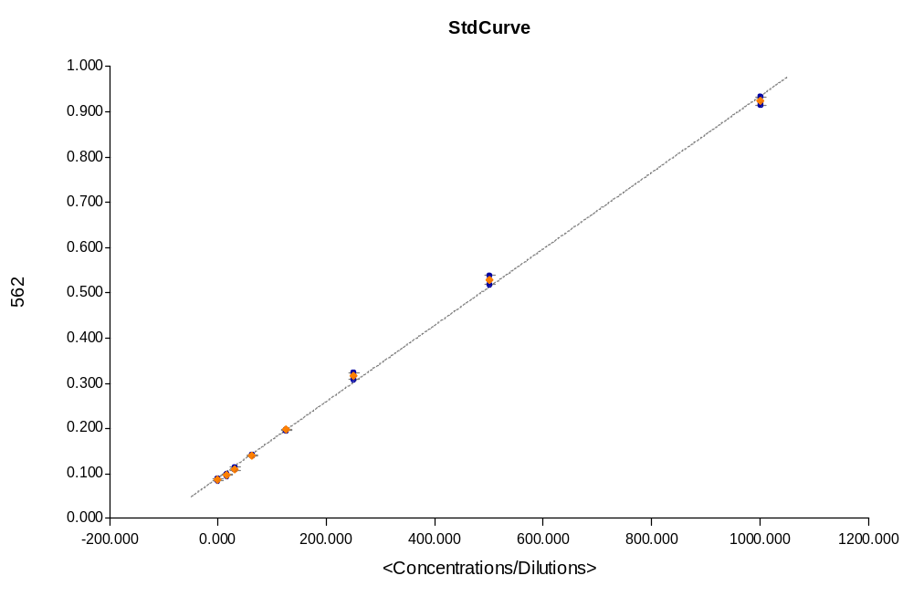
Curve Name | Curve Formula | A | B | R2
StdCurve | Y=A*X+B | 0.000844 | 0.0912 | 0.999

Referenced Documents
Mertins P (2014) “Ischemia in tumors induces early and sustained phosphorylation changes in kinase pathways but does not affect global protein levels. Mol. Cellular Proteomics. 13, 1690-1704.

Abbreviations
EDTA, Ethylenediaminetetraacetic acid
PMSF, Phenylmethylsulfonyl fluoride
Tris-HCl, tris(hydroxymethyl)aminomethane-Hydrochloride
NaCl, Sodium Chloride
NaF, Sodium Fluoride
Tris, tris(hydroxymethyl)aminomethane
EtOH, Ethanol
RT, Room temperature
HCl, Hydrochloric acid
BCA, bicinchoninic acid

