CPTAC STANDARD OPERATING PROCEDURE

Title: Preparation of Peptides from High-purity Bovine Serum Albumin
Version: 1.0 | Authors: Townsend Lab
Date: March, 2021

Purpose
This document describes the preparation of purified tryptic peptides from high purity bovine serum albumin (BSA). The desalted peptides are used as a simple matrix and a carrier for the preparation of standard solutions of synthetic peptides (Experiments 1 and 2).

Scope
This procedure is used to reduce, alkylate and digest BSA with trypsin. The desalting of the tryptic peptides using sold phase extraction and quantification of the purified peptides is described.

Responsibilities
It is the responsibility of person(s) performing this procedure to be familiar with laboratory safety procedures and relevant good practice procedures of laboratory biochemistry and analytical chemistry. The interpretation of results must be performed by person(s) trained in the procedure and in the interpretation of these data.

Materials

Reagents
- Bovine Serum Albumin (BSA) (Millipore Sigma, cat. no. A0281)
- Urea (Millipore Sigma, cat. no. U4884)
- Tris(hydroxymethyl)aminomethane hydrochloride) (Tris-HCl)) (ThermoFisher Scientific, cat. no. BP152)
- Tris(2-carboxyethyl)phosphine (TCEP) (ThermoFisher Scientific, cat. no. 77720)

- Iodoacetamide (IAM) (Millipore Sigma, cat. no. A3221)
- Trypsin (ThermoFisher Scientific, cat. no. PRV5113)
- Acetonitrile (MeCN), LC-MS grade (JT Baker, cat. no. 9829-03)
- Water, HPLC grade (JT Baker, cat. no. 4218-03)
- Methanol (MeOH) (Honeywell Fluka, cat. no. 34966)
- Formic Acid (FA) (Honeywell Fluka, cat. no. 94318)
- Trifluoroacetic acid (TFA) (Pierce, cat. no. 28904)
- Quantitative Fluorometric Peptide Assay (Pierce, cat. no. 23290)

Equipment
- Express SpeedVac Concentrator SC250 (ThermoFisher Scientific, cat. no. 20548130)
- Superspeed Centrifuge (Sorval, mod. no. RC6+)
- Virtis AdVantage XL Freeze Dryer (SP Scientific, cat. no. AD20XL)
- Thermomixer F (Eppendorf, cat. no. 5400205)
- Synergy H1 Hybrid Multi-mode Reader (Biotek, mod. no. H1M)
- 1.7-mL microcentrifuge tubes (Axygen, cat. no.MC-175-C)
- Autosampler vials, 250 μL polypropylene crimptop (VWR, cat. no. 200 046)
- Snap caps for autosampler vials, 11 mm, PTFE/DK blue silicone (SUN SRI, cat. no. 501 390)
- 15-mL conical centrifuge tubes (ThermoFisher Scientific, cat. no. 05-539-12)
- Sep-Pak Vac 3 cc (200 mg) tC18 Cartridges (Waters, cat. no. WAT054925)
- 4-mL glass vials (ThermoFisher Scientific, cat. no. 03-339-22B)
- Black flat bottom 96 well plate (ThermoFisher Scientific, cat. no. 137103)
- Pipettors (P1000, P200, P20, P10, P2), (Rainin)
- Pipette tips (Rainin, cat. no. 30389294, 30389299, 30389298)

Software
- Skyline (MacCross Lab Software, https://skyline.ms/project/home/software/Skyline/begin.view)

Reagent setup
Endoprotease digestion buffer (50 mM Tris HCl (pH 8.0))
Weigh 0.303 g Tris into a 50 mL conical tube. Add 40 mL of HPLC water. Adjust pH to 8.0 and add water to a final volume of 50 mL.

Reduction reagent (10 mM TCEP in 8 M urea buffer)
Weigh 7.7 g of urea into a 15 mL conical tube. Add 15 mL of 50 mM Tris-HCl (pH 8.0) containing 30 µL of 0.5 M TCEP.

Preparation of digestion enzymes
Add 1 mL of 50 mM Tris-HCl (pH 8.0) to the lyophilized trypsin (50 mg). Take out 200 µL and dilute with 44.8 mL of 50 mM Tris-HCl (pH 8.0).

Solid-phase extraction solvents
50% (vol/vol) TFA
Dilute concentrated TFA with an equal volume of HPLC water.

50% (vol/vol) MeCN in 0.1% FA (vol/vol)
Combine 50 mL of FA stock, with 24.95 mL of water, and 25 mL MeCN.

0.1% (vol/vol) TFA
Add 50 µL of neat TFA to 49.95 mL of water.

1.0% (vol/vol) FA
Add 500 µL of reagent FA to 49.5 mL of water.

2.0% (vol/vol) FA
Add 1 mL of reagent FA to 49 mL of water.

Preparation of BSA standard solutions
BSA digest standard (1 mg/mL) is serially diluted in water. Standard solutions (75 µL) are mixed with 75 µL of DI water to make 150 µL of a two-fold diluted series as shown below:
STD 1 0.0 ng/µL BSA
STD 2 3.4 ng/µL BSA
STD 3 7.8 ng/µL BSA
STD 4 15.6 ng/µL BSA
STD 5 31.3 ng/µL BSA
STD 6 62.5 ng/µL BSA
STD 7 125 ng/µL BSA
STD 8 250 ng/µL BSA

Procedure

Preparation of tryptic digest of BSA
- Add 8 M urea buffer containing 10 mM TCEP to 500 mg of lyophilized high purity BSA. Incubate at RT for 30 min.
- Alkylate BSA with 20 mM IAM for 1 h in the dark at RT.
- Dilute urea concentration to 2 M by adding to each of the four 15 mL concial tube 11.25 mL of 50 mM Tris-HCl (pH 8.0) containing trypsin. Add 3.75 mL of reduced and alkylated BSA.
- Digest overnight at RT.
- Stop the digestion by adding 50% (vol/vol) TFA to a final concentration of 0.1% (vol/vol).
- Desalt peptides using solid phase extraction.

Solid phase extraction of peptides
- Label 15 mL conical tubes : MeOH, wash, equilibrate, desalt. One of each is required per SepPak.
- Wet SepPak with 3 mL of 100% MeOH. Collect flow-through in conical tube marked “MeOH” and discard. Wash SepPak with 3 mL of 50% (vol/vol) MeCN, 0.1% (vol/vol) FA. Collect flow-through in conical tube and discard.
- Equilibrate SepPak by washing four times with 3 mL of 0.1% (vol/vol) TFA. Collect flow-through in conical tube and discard.
- Load acidified digest onto SepPak using gravity flow. Collect flow through in a 15 mL conical and re-load the flow through onto the same SepPak.
- Wash the SepPak with 3x3 mL 0.1% (vol/vol) TFA. Collect washes and discard.
- Wash cartridge with 1x3 mL 1% (vol/vol) FA.
- Elute peptides with 2x 1.5 mL 50% (vol/vol) MeCN in 0.1% (vol/vol) FA and collect flow-through in the 4 mL glass vial.
- Freeze the peptide eluates at -80°C for 30 min or until the lyophilizer shelf temperature has reached -60°C.
- Turn on Vantage lyophilizer and set shelf temperature to -60°C. It will take 30-45 min to reach temperature.
- Place frozen samples on the pre-chilled shelf with the cap half a turn open.
- Turn on the condenser and set temperature to -70°C. Once temperature is reached, turn on the vacuum. Set vacuum is to 200 mTor.
- Once vacuum is reached, bring shelf temperature to 0°C and lyophilize samples for ~ 16 h.
- Collect samples from lyophilizer after vacuum release has brought chamber to atmospheric pressure and condenser is off.
- 20. Dissolve dried peptides in 2% (vol/vol) MeCN in water.

Determination of peptide concentration
- Remove a 2 µL aliquot and dilute 5.25-fold with 8.5 µL of water, mixing well.
- Pipette 10 µL of diluted sample in triplicate wells from each SePak preparation into the black, flat-bottomed fluorescence-compatible microplate.
- Dilute the BSA peptide standard into an 8 point standard curve, ranging in concentration from 0 to 250 ng/µL.
- Pipette 10 µL of each peptide standard in to one well, each concentration in triplicate.
- Add 70 µL of Fluorometric Peptide Assay Buffer to each well.
- Add 20 µL of Fluorometric Peptide Assay Reagent to each well.
- Incubate at RT for 5 min.
- Measure the fluorescence using Ex/Em at 390 nm/475 nm (BioTek Synergy H1 Hybrid Reader).
- Use the standard curve to determine the peptide concentration of each desalted peptide preparation.
- Prepare 5 mg aliquots based on the peptide concentration and add 50% (vol/vol) TFA to a final concentration of 0.1% TFA (vol/vol). Store at -80 °C.

Expected results
Example output from plate reader
 | 1 | 2 | 3 | 4 | 5 | 6 | 7 | 8 | 9 | 10 | 11 | 12
A | STDm1 | STDm1 | STDm1 | SPL1 | SPL1 |  |  |  |  |  |  |  | Well ID
A | 0 | 0 | 0 |  |  |  |  |  |  |  |  |  | Conc/Dil
B | STDm2 | STDm2 | STDm2 | SPL2 | SPL2 |  |  |  |  |  |  |  | Well ID
B | 3.9 | 3.9 | 3.9 |  |  |  |  |  |  |  |  |  | Conc/Dil
C | STDm3 | STDm3 | STDm3 | SPL3 | SPL3 |  |  |  |  |  |  |  | Well ID
C | 7.8 | 7.8 | 7.8 |  |  |  |  |  |  |  |  |  | Conc/Dil
D | STDm4 | STDm4 | STDm4 |  |  |  |  |  |  |  |  |  | Well ID
D | 15.6 | 15.6 | 15.6 |  |  |  |  |  |  |  |  |  | Conc/Dil
E | STDm5 | STDm5 | STDm5 |  |  |  |  |  |  |  |  |  | Well ID
E | 31.3 | 31.3 | 31.3 |  |  |  |  |  |  |  |  |  | Conc/Dil
F | STDm6 | STDm6 | STDm6 |  |  |  |  |  |  |  |  |  | Well ID
F | 62.5 | 62.5 | 62.5 |  |  |  |  |  |  |  |  |  | Conc/Dil
G | STDm7 | STDm7 | STDm7 |  |  |  |  |  |  |  |  |  | Well ID
G | 125 | 125 | 125 |  |  |  |  |  |  |  |  |  | Conc/Dil
H | STDm8 | STDm8 | STDm8 |  |  |  |  |  |  |  |  |  | Well ID
H | 250 | 250 | 250 |  |  |  |  |  |  |  |  |  | Conc/Dil

 | 1 | 2 | 3 | 4 | 5 | 6 | 7 | 8 | 9 | 10 | 11 | 12
A | 176 | 244 | 216 | 28884 | 26995 |  |  |  |  |  |  |  | 390,475
A | <0.000 | <0.000 | <0.000 | 149.903 | 139.879 |  |  |  |  |  |  |  | [Conc]
B | 949 | 894 | 932 | 13476 | 15204 |  |  |  |  |  |  |  | 390,475
B | 1.654 | 1.363 | 1.564 | 68.134 | 77.305 |  |  |  |  |  |  |  | [Conc]
C | 1721 | 1755 | 1630 | 9041 | 9037 |  |  |  |  |  |  |  | 390,475
C | 5.751 | 5.932 | 5.268 | 44.598 | 44.577 |  |  |  |  |  |  |  | [Conc]
D | 3492 | 3486 | 3224 |  |  |  |  |  |  |  |  |  | 390,475
D | 15.15 | 15.118 | 13.728 |  |  |  |  |  |  |  |  |  | [Conc]
E | 6330 | 6269 | 6711 |  |  |  |  |  |  |  |  |  | 390,475
E | 30.211 | 29.887 | 32.233 |  |  |  |  |  |  |  |  |  | [Conc]
F | 13512 | 13541 | 12898 |  |  |  |  |  |  |  |  |  | 390,475
F | 68.325 | 68.479 | 65.067 |  |  |  |  |  |  |  |  |  | [Conc]
G | 23253 | 27064 | 27250 |  |  |  |  |  |  |  |  |  | 390,475
G | 120.02 | 140.245 | 141.232 |  |  |  |  |  |  |  |  |  | [Conc]
H | 45453 | 47115 | 47624 |  |  |  |  |  |  |  |  |  | 390,475
H | 237.834 | 246.654 | 249.355 |  |  |  |  |  |  |  |  |  | [Conc]

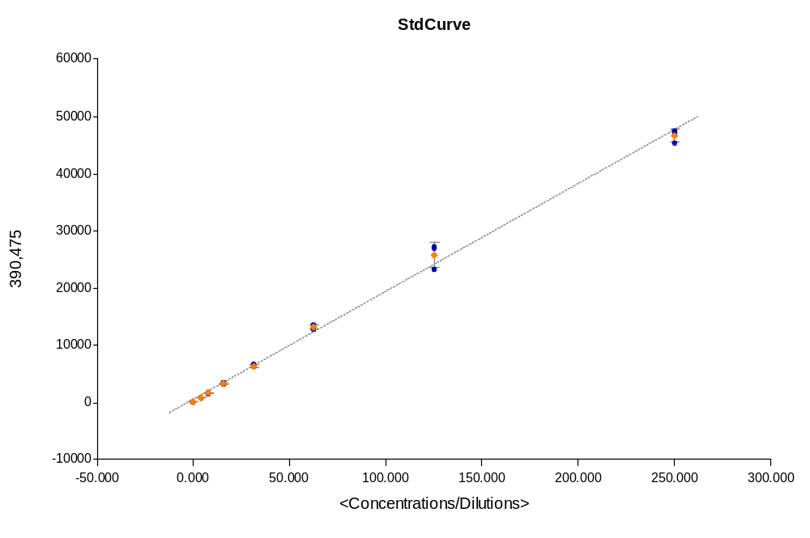

Curve Name | Curve Formula | A | B | R2
StdCurve | Y=A*X+B | 188 | 637 | 0.997

Abbreviations
BSA, bovine serum albumin
Tris, tris(hydroxymethyl)aminomethane
TCEP, tris(2-carboxyethyl)phosphine
MeCN, Acetonitrile
MeOH, Methanol
FA, Formic acid
TFA, Trifluoroacetic acid

