CPTAC STANDARD OPERATING PROCEDURE

Title: Optimizing Mass Spectrometer Performance for CPTAC Experiments 1 and 2
WU-SOP-MS-1-2021  Version: 1 | Author: Townsend Lab
Date: March, 2021

Purpose
The purpose of this document is to describe the procedures for calibration and optimization specifications for the high-resolution hybrid quadrupole-Orbitrap mass spectrometer that is used to generate scheduled full scan MS2 data for CPTAC Experiments 1 and 2 (https://assays.cancer.gov/guidance-document/). The SOP procedure can be executed with either EASY-nanoLC™ or the Dionex Ultimate™ 3000 RSLC nano-LC systems coupled to a Q-Exactive™ mass spectrometer (ThermoFisher Scientific).

Scope
This procedure encompasses the i) preparation of standard solutons to assess instrument performance; ii) spectral acquisition of benchmark peptides iii) optimization procedure; and iv) assessment of instrument performance after calibration and tuning.

Responsibilities
It is the responsibility of person(s) performing this procedure to be familiar with laboratory safety procedures and relevant good practice procedures of laboratory biochemistry and analytical chemistry. The interpretation of results must be performed by person(s) trained in the procedure and trained in the interpretation of these data.

Page 1 of 10

Materials
Reagents
- Pierce Peptide Retention Time Calibration Mix (PRTC) (ThermoFisher Scientific, cat. no. 88320)
- Pierce HeLa Protein Digest Standard, (ThermoFisher Scientific, cat. no. 88328)
- Pierce LTQ Velos ESI Positive Ion Calibration Solution (ThermoFisher Scientific, cat. no. 88323)
- Pierce LTQ Velos ESI Negative Ion Calibration Solution (ThermoFisher Scientific, cat. no. 88324)
- Methanol (MeOH) (Millipore Sigma, cat. no. 34860)
- Water (“house” DI water)
- Water (HPLC grade) (J.T. Baker, cat. no. 4218-03)
- Formic acid 98% (FA) (vol/vol) (Honeywell Fluka, cat. no. 94318)
- Nitric Acid 69% (vol/vol) (Honeywell Fluka, cat. no. 84385)
- Acetonitrile >99.9% (MeCN) (vol/vol) (Honeywell Fluka, cat. no. 34967)
- Alconox (Fisher, cat. no. 16-000-104)
Equipment
- Q-Exactive quadrupole-Orbitrap™ mass spectrometer (ThermoFisher Scientific, cat. no. IQLAAEGAAPFALGMAZR) NOTE: Additional details of instrument setup and operation is available at the ThermoFisher Scientific Customer Manual website. (https://www.thermofisher.com/us/en/home/products-and-services/promotions/industrial/how-locate-user-manuals-documentation-online.html)
- EASY-Spray™ source (ThermoFisher Scientific, cat. no. ES081)
- EASY-nLC™ 1000 (ThermoFisher Scientific, cat. no. LC120)
- HESI-II probe (ThermoFisher Scientific, cat. no. IQLAAEGABBFACNMAGY)
- LC to Source Connection: Nano Viper TM Tubing (cat. no. 6041.5261)
- EASY-Spray™ column (PepMap, C18, 2 µm particles, 50 cm x 75 µm ID) (ThermoFisher Scientific, cat. no. ES803a)
- Sonicator (VWR, cat. no. 97043-936)
- Syringe (250 µL) (Hamilton, cat. no. 8175)
- PEEK Tubing, red, 1/16” x 0.005” (IDEX, cat. no. 00301-22912)
- Graduated cylinders (10 mL and 100 mL)
- Glass media bottle (Pyrex).

Page 2 of 10

Reagent setup
1 % (w/vol) Alconox cleaning solution
Weigh 1g of Alconox into a beaker, add 100mL warm tap water, stir to dissolve.

0.1 % (vol/vol) FA
Combine 100 µL FA stock and 97.9 mL HPCL grade water. Store in glass at RT for up to 1 month.

Mobile Phase A
Combine 2.5 mL FA stock with 245 mL HPLC grade water. Store in glass at RT for up to 1 month.

Mobile Phase B
Combine 2.5 mL FA stock with 245 mL MeCN. Store in glass at RT for up to 1 month.

Peptide Retention Time Calibration Secondary Stock Solution (50 fmol/µl)
Combine 50 µL of PRTC with 450 µL 0.1% FA. Vortex for 15-30 sec and spin down to collect solution at the bottom of the vial. Pipette 20 µL aliquots into autosampler vials and store at -20 °C for up to 6 months.

HeLa Standard (100 ng/µl HeLa digest)
Add 200 µL of PRTC secondary stock to HeLa vial. Vortex for 30 sec. Pipette 10 µL into autosampler vials and store at -20 °C for up to 6 months.

30% (vol/vol) Nitric acid
Combine 60 mL Nitric acid and 78 mL HPCL grade water. Invert to mix. Store in glass at RT for up to 1 month.

Procedure

Preparation of Instrument for Analysis of Benchmark Solutions
Align EASY Spray Source™
(This procedure assumes that the instrument is clean and ready to run)
- Check the column emitter alignment by turning the instrument into standby in the tune window before starting this procedure.
- Use the emitter positioning tool to set x, y, and z positions for column emitter alignment and proximity to the ion transfer tube.
- Center the tip of the emitter positioning tool on the ion transfer tube.
- Adjustments in the x direction (side to side) can be made by turning the left-side hex socket-head screw on the housing of the EASY-spray™ source.
- Adjustments in the y direction (up and down) can be made by turning the bottom hex socket-head screw.
- Adjustments in the z direction (front to back) can be made by turning the Z-axis positioning control knob located below the column holder. The emitter positioning tool should touch the ion transfer tube.
- Remove the emitter positioning tool and replace it with the column.

Page 3 of 10

Check spray stability
- Turn instrument into standby in the tune window.
- Start flow on the LC system at 300 nL/min with 20% (vol/vol) B. A bubble should form at the emitter tip and the backpressure should stabilize (between 550-650 bar, depending on usage history of the column.

8. Turn instrument into standby in the tune window.
9. Start flow on the LC system at 300 nL/min with 20% (vol/vol) B. A bubble should form at the emitter tip and the backpressure should stabilize (between 550-650 bar, depending on usage history of the column.
10. Load the tune file for nano-flow and turn instrument ON. The bubble at the end of the emitter tip should start getting smaller and should disappear over time (e.g. xx min). If pulsing or bubble formation persists, adjust the spray voltage (typically around 2-2.5 kV).
- Check TIC variation in the tune window under instrument, current scan (top right). The variation should be <10% to be considered stable.

Preparing to Run the Q Exactive
- Tuning the instrument optimizes source parameters with regards to ionization technique and LC flow only. All other optics have been optimized at the factory and only need to be calibrated after venting and cleaning or if instrument evaluation fails after
- installation of new parts. Contact ThermoFisher technical support or follow instructions in the Operating manual.
- Three parameters are used for optimization: Spray voltage (2-2.5 kV), Capillary temperature (250-350 °C), and S-lens RF level (50-60).
- Adjust parameters to maximize signal as described in the Q-Exactive™. manual.

Assessment of Instrument Performance using Benchmark Solutions
  - Setup MS Properties for PRTC (see Table 1)
Table 1. Instrument Parameters
 | PRTC | HeLa
Global Settings
User Role | Advanced | Advanced
Use lock masses | off | off
Chromatography peak width (seconds) | 15 s | 15 s
Gradient Time (minutes) | 36 min | 133 min
General
Polarity | positive | positive
Full MS
Microscans | 1 | 1
Resolution | 70,000 | 70,000
AGC target | 3 x 10⁶ | 1 x 10⁶
Maximum IT | 50 ms | 60 ms
Scan range (m/z) | 350-2,000 m/z | 375-1,500 m/z
Spectrum data type | profile | Profile

Page 4 of 10

Table 1. Instrument Parameters
 | PRTC | HeLa
dd-MS2 / dd-SIM DIA
Microscans | Microscans | Microscans
Resolution | Resolution | Resolution
AGC target | AGC target | AGC target
Maximum IT | Maximum IT | Maximum IT
Loop count | Loop count | Loop count
Microscans | Microscans | Microscans
TopN |  | 10
MSX isochronous Its | on
Isolation window | 2.0 m/z | 2.0 m/z
scan range: | N/A | 200-2000 m/z
Fixed first mass | N/A | 100 m/z
NCE / stepped | 27 | 27
Spectrum data type: profile | profile | Profile
Underfill ratio | N/A | 2%
Minimum AGC target | N/A | 2 x 10³
Intensity threshold | N/A | 3.3 x 10⁴
Apex trigger | N/A | N/A
Charge exclusion unassigned | N/A | 1

17. Import inclusion list into MS DIA method (see example Table 2)
Table 2. Retention Times for Pierce Calibration Peptides
m/z | CS [z] | Peptide
493.77 | 2 | SSAAPPPPPR
613.32 | 2 | GISNEGQNASIK
496.29 | 2 | HVLTSIGEK
451.28 | 2 | DIPVPKPK
422.74 | 2 | IGDYAGIK
695.83 | 2 | TASEFDSAIAQDK
586.80 | 2 | SAAGAFGPELSR
773.90 | 2 | ELGQSGVDTYLQTK
558.33 | 2 | GLILVGGYGTR
801.41 | 2 | GILFVGSGVSGGEEGAR
745.39 | 2 | SFANQPLEVVYSK
498.81 | 2 | LTILEELR
573.30 | 2 | NGFILDGFPR
680.37 | 2 | ELASGLSFPVGFK
787.42 | 2 | LSSEAPALFQFDLK

Page 5 of 10

- Prepare PRTC working test solution and inject 2 µL on column (WU-SOP-LC1-2021).
- Begin data acquisition
- Import LC-MS analyses with the standard PRTC samples into Skyline to assess intensity, peak shape, retention time and mass error for the 15 precursor m/z values, and the y-series transitions from each precursor spectrum during acquisition of data for experiments 1 and 2. Benchmark specifications include: TIC of 1e9 or better, MS1 intensity of +/- 20% intensity compared to reference at outset, MS2 INTENSITY of +/- 20% intensity compared to reference at outset, and retention times within 0.3 min of the average retention time. The optimization steps and LC-trouble shooting are initiated if instrument fails to meet specifications (Fig. 1).
- Setup MS Properties for Hela (see Table 1) and repeat as for PRTC above.

Page 6 of 10

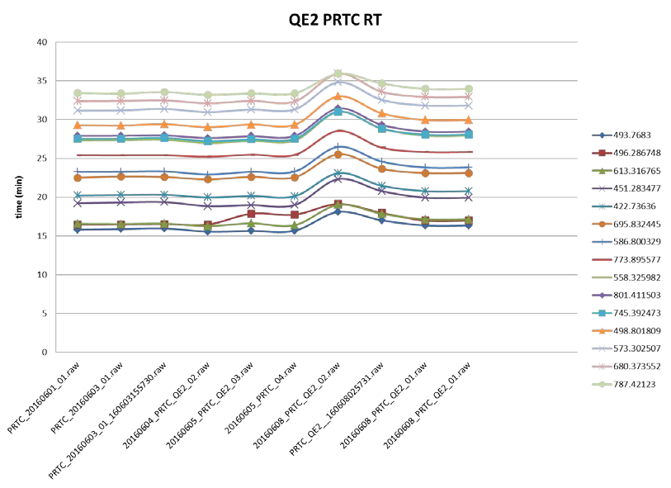
A
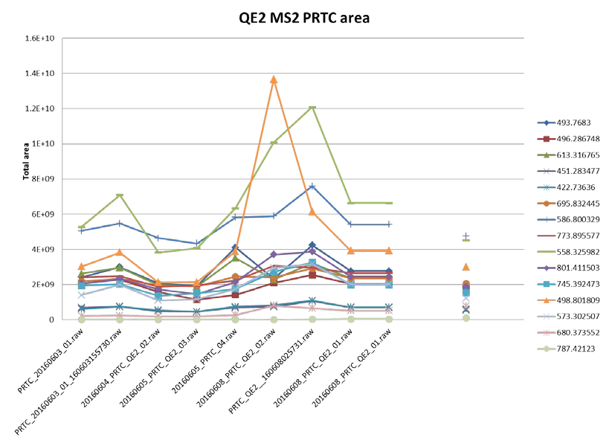
B
Figure 1. PRTC Peptide Data to Assess Instrument Performance. A) Retention times for the PRTC benchmark peptides over a five day period ; B) Peak area sum for all y ion transitions for each benchmark peptide.

Page 7 of 10

Procedure for Mass Calibration – Positive Mode
- Attach the HESI-II source and set parameters as shown in Table 3.
- Infuse the standard at 3 µl/min
- Check that all m/z signals from the 15 peptides are observed and their intensities are at least 1 x e⁸ in the MS1 scans, and with a variations are less than 10%, and IT is less than 5 ms.
- Start calibration. At the end of the procedure a dialog window will appear with status of the calibration. All successful calibrations are automatically saved in the master.cal file.
- Remove HESI-II source and install EASY-spray™ source.
Table 3. Mass Calibration Parameters
Sheath gas flow rate | 10
AUX gas flow rate | 0
Sweep gas flow rate | 0
Spray Voltage (kV) | 3.5
Spray current | (actual 0.8)
Capillary temp (°C) | 300
S-lens RF level | 50.0
Heater temp (°C) | 0 or ‘off’ (actual 47)

Procedure to Clean ion transfer tube
Note: cleaning past the S-lens is performed by Unity Lab services.
- Turn the MS off by clicking the On/Standby button in the tune software window to shut off all high voltages and sheath and auxiliary gas.
- Remove the EASY-spray™ source. Wait for the front end to cool down before proceeding.
- Remove the ion transfer tube using the specialized tool.
- Sonicate ion transfer tube in water, followed by 30% nitric acid, then DI water for 20 min each. Rinse with MeOH and dry by blowing off with nitrogen. Check if ion transfer tube is clean using a microscope.
- Install ion transfer tube (make sure the o-ring on the ion source interface is seated correctly before installing the ion transfer tube).
- Install HESI-II source and follow mass calibration instructions (see above)
- Remove HESI-II source and install EASY-spray™ source.

Clean the S-lens
- Turn the MS off by clicking the On/Standby button in the tune software window to shut off all high voltages and sheath and auxiliary gas.
- Place electronics service switch, located on the power panel, in Service Mode position
- Put the main power circuit breaker switch of the MS in the Off position.
- Remove the nano -source. Wait for the front end to cool down before proceeding.
- Remove the ion source interface using the lever tool. Pull the assembly straight out.
- Remove the S-lens from the interface cage. Remove the exit lens by loosening the two thumb screws.

Page 8 of 10

- Clean the exit lens and S-lens plates with a 6000 grit MICRO-MESH fastened to a small spatula that has been moistened in 1% (wt/vol) Alconox solution. Use a swab for the
Circular holes in the plates of the S-lens.
- Rinse well with warm tap water, followed by rinsing with DI water. Sonicate for 20 min in MeOH. Dry with nitrogen.
- Reassemble the exit lens, S-lens and interface cage. Insert interface assembly and push until you hear a click. Install ion transfer tube (make sure the O-ring on the ion source interface is seated correctly before installing the ion transfer tube).
- Open the tune window on the computer before starting the mass spectrometer.
- Place main power circuit breaker switch to the ON position. The forepump and turbomolecular pumps should start automatically. Allow mass spectrometer to pump down for 5 min.
- Turn electronics service switch to Operation Mode.
- Monitor the pump speed in the tune window to make sure they reach operating speed.
- To start the bakeout procedure, put the system in off condition in the Tune software window; click the Vacuum/Bakeout task panel; set desired bakeout length (minimum 12 h); click on bakeout and confirm.
- After bakeout the system needs 3-6 h to cool down and stabilize before instrument calibration can be performed.

Referenced Documents
“Overview of assay characterization for the CPTAC assay portal”, CPTAC Assay Development Working Group (https://assays.cancer.gov/)
WU-SOP-MS-2-2021
WU-SOP-LC1-2021
Exactive™ Series Operating Manual, ThermoFisher Scientific
EASY-Spray Series Ion Source, ThermoFisher Scientific
ThermoFisher Scientific Customer Manuals website.

Abbreviations
MeCN, acetonitrile
FA, formic acid
LC-MS, nano-LC interfaced to a high-resolution quadrupole-orbitrap mass spectrometer as described in WU-SOP-LC-1 and WU-SOP-MS-1
Q.S., quantum satis
ms, milliseconds
Sec, seconds
Min, minutes
H, hours
MS, mass spectrometer
PRM, parallel reaction monitoring mass spectrometry
PRTC, Peptide Retention Time Calibration
RT, Room Temperature
TIC, Total Ion Current
IT, fill time
ID, internal diameter

Page 9 of 10

DIA, Data-Independent-Acquisition
Rcf, Relative centrifugal force
kV, kilo volt
Rf, Radio Frequency
MS1, mass spectra of peptide precursors
MS2, fragmentation mass spectra of peptides selected in narrow mass range (2 Da) from MS1 scan
eV, electron volt

Page 10 of 10

