CPTAC STANDARD OPERATING PROCEDURE
Title: Nano-Liquid Chromatography for CPTAC Experiments 1 and 2
SOP: WU-SOP-LC1-2021

Version: 1 Authors: Townsend Lab

Date: March, 2021
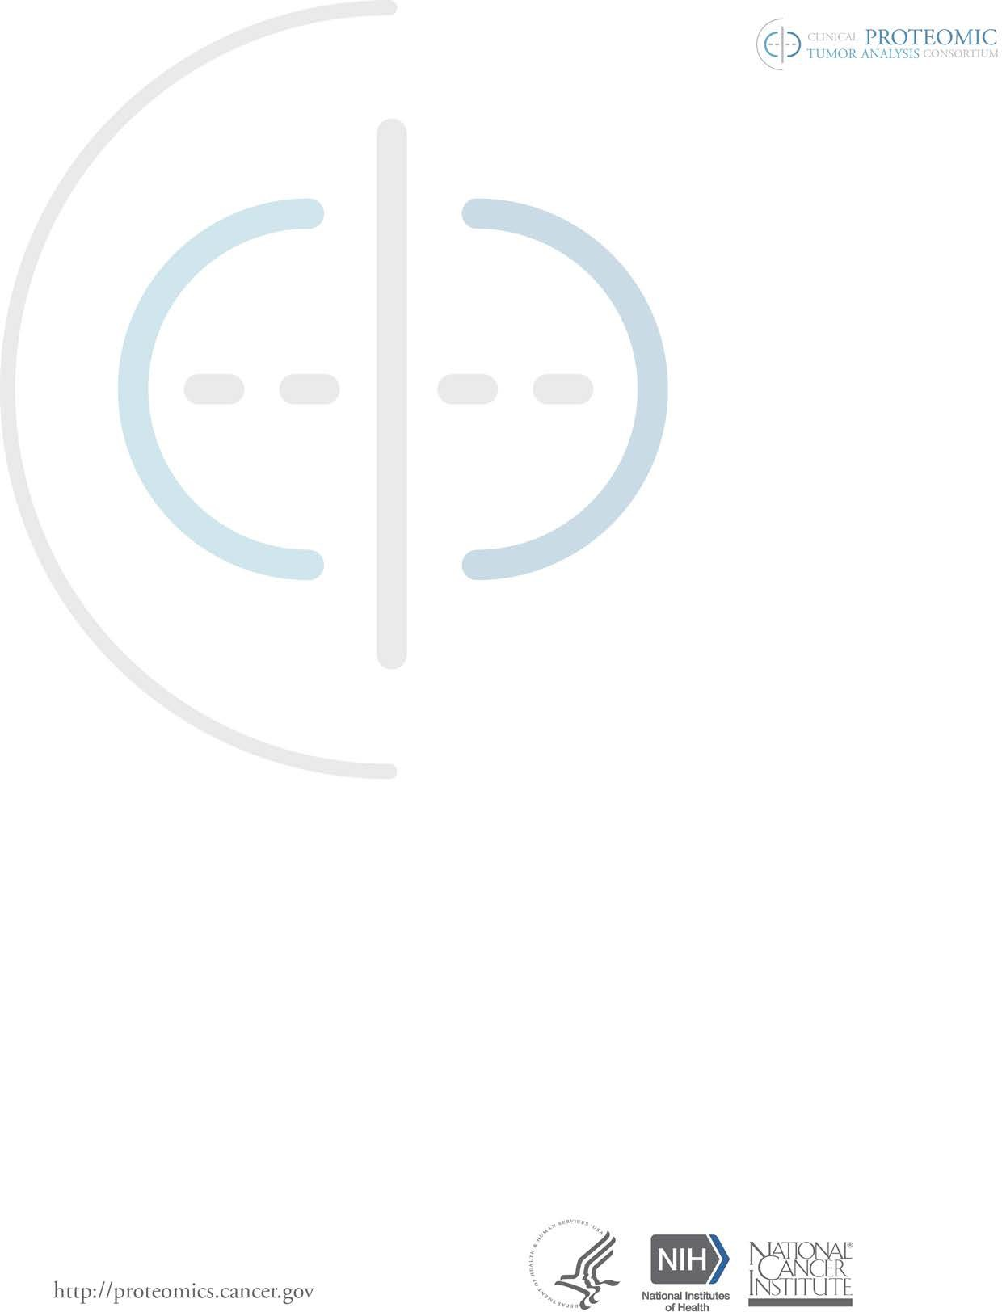

Purpose
This document describes the configuration, instrument specifications and LC methods for nano-liquid chromatography (nano-LC) using Dionex Ultimate™ 3000 RSLC nano system that is interfaced to a quadrupole-Orbitrap (ThermoFisher, Q-Exactive™). The system is used to acquire scheduled full scan MS2 spectra (parallel reaction monitoring - PRM) of standard admixtures of natural abundance (L, light) and stable isotope-labeled (H, heavy) high-purity synthetic peptides to perform CPTAC Experiments 1 and 2 (WU-SOP-EXP1-2021 and WU-SOP-EXP2-2021).
Scope
The procedures encompass the setup of a single column nano-LC for generating the MS data for Experiments 1 and 2. The configuration, specifications and methods for the mass spectrometer are described in WU-SOP-MS1-2021 and WU-SOP-MS2-2021.
Responsibilities
It is the responsibility of person(s) performing this procedure to be familiar with laboratory safety procedures and relevant good practice procedures of laboratory biochemistry and analytical chemistry. The interpretation of results must be performed by person(s) trained in the procedure and trained in the interpretation of these data.

Materials

Reagents
- Water (JT Baker, cat. no. 4218-03)
- Formic acid 98% (vol/vol) (FA) (Honeywell Fluka, cat. no. 94318-250mL)

Page 1 of 6

- Acetonitrile (MeCN), >99.9% (vol/vol) (JT Baker, cat. no. 9829-03)
- Methanol (MeOH) (Honeywell, cat. no. 34966 4x4L)
- Pierce Retention Time Calibration Mixture (PRTC) (Thermo Fisher Scientific, cat. no. 88321)
- HeLa Protein Digest Standard (Thermo Fisher Scientific, cat. no. 88328)

Equipment
- Ultimate™ 3000 RSLCnano (Thermo Fisher Scientific, cat. no. ULTIM3000RSLCNANO)
- EASY-Spray Column: 75 µm x 50 cm PepMap™ RSLC C18, 2 µm, 100 Å (Thermo Scientific, cat. no. ES803)
- Injection loop: 20 µL PEEKsil™, 100 µm (Thermo Scientific, cat. no. LC472)
- Sonicator (VWR, model no. 150D)

Reagent setup
Mobile Phase A
Water containing 1% (vol/vol) FA
Combine 2.5 mL FA stock with 247.5 mL HPLC grade water. Store in glass at room temperature for up to 1 month.

Mobile Phase B
MeCN containing 1% (vol/vol) Formic Acid (FA) (JT Baker, cat. no. 9829-03, Honeywell Fluka, cat. no. 94318-250mL).
Combine 2.5 mL FA stock with 247.5 mL MeCN. Store in glass at room temperature for up to 1 month

Rear Seal Wash Solution
10 % (vol/vol) methanol, 0.1 % (vol/vol) FA in water
Combine 100 mL MeOH, 1 mL FA with 899 mL of water. Store in glass at room temperature for up to 1 month

Syringe Solution
10% (vol/vol) methanol Syringe buffer
Combine 20mL MeOH with 180 mL of water. Store in glass at room temperature for up to 1 month.

Sample pickup Solution A
1 % (vol/vol) FA in water

Loop/needle wash buffer B
1 % (vol/vol) FA in MeCN

Page 2 of 6
Procedure

Solution preparation and setup
- Prepare mobile phase solutions in glass media bottles and sonicate for 15 min to degas with the cap loosened.
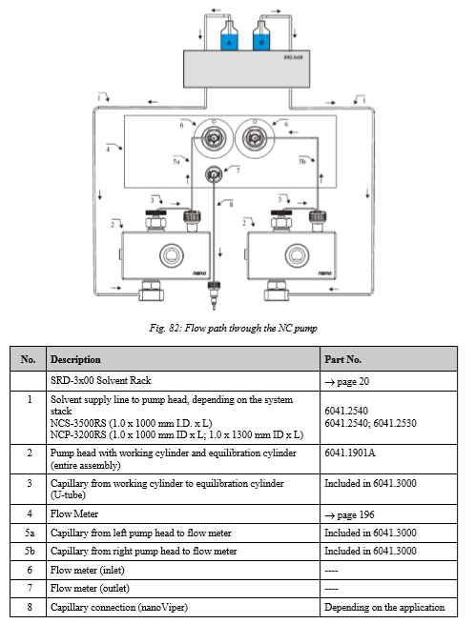
- The flow path for the Dionex RSLCnano system that is used to execute Experiments 1 and 2 is shown in Diagram I.
Diagram I.

Page 3 of 6

3. The Dionex RSLC nano is configured in the configuration file in the Xcalibur® software.
4. Methods for the autosampler and LC are written in each method file. For further details, see user manual.
5. The method used to analyze samples (e.g. calibrants or standard peptide H/L admixtures) is controlled by event sequence and gradient as shown in the following Tables.
Table I. Autosampler Method for PRM Sample Run:
Step | Operation | Value | Parameter | Speed | Description
1 | Needle Wash | 3x25 µL | Injector load | 4 µL/sec | Wash needle, equilibrate to buffer A
2 | Sample Pickup | 2.5 µL | Injector load | 0.05 µL/sec | Pull up sample
3 | Buffer A pickup |  | Injector Load | 0.05 µL/sec | Pull up sample into loop
4 | Sample Load | 1060 sec | Injector Inject | 0.3 µL/min | Loading sample to column
5 | Autosampler wash | 100 µL |  | 4 µL/sec
6 | END
- Set the Dionex RSLCnano method for PRM sample run to include a flow rate of 300 nL/min, at 50 °C.
- Pre-equilibrate column to initial conditions (29 min at 300 nL/min).
- Load sample for 1060 sec at 300nL/min.
Time interval (min) | Gradient (%B)
0 | 1
5 | 1
35 | 7
40 | 10
92 | 30
1 | 95
17 | 95
1 | 1
19 | 1

Table III. Autosampler Method for System Performance Run
Step | Operation | Value | Parameter | Speed | Description
1 | Needle wash | 3x25 µL | Injector load | 4 µL/sec | Wash needle, equilibrate to buffer A
2 | Sample Pickup | 2 µL | Injector load | 0.05 µL/sec | Pull up sample
3 | Buffer A pickup |  | Injector load | 0.05 µL/sec | Pull up sample into loop
4 | Sample Load | 1060 sec | Injector Inject | 0.3 µL/min | Loading sample onto column
5 | Autosampler wash | 100 µL |  | 4 µL/sec
6 | END

Page 4 of 6

Table IV. Timetable for Column Flow for System Performance PRTC’s
Time interval (Min) | Gradient (%B)
0 | 1
5 | 1
35 | 7
40 | 10
100 | 20
13 | 95
7 | 95
1 | 1
19 | 1

Table V. Timetable for Column Flow for System Performance Hela Digest
Time interval (min) | Gradient (%B)
0 | 2
5 | 2
100 | 20
20 | 32
1 | 95
17 | 95
1 | 2
20 | 2

Cycle Time or system performance test and PRM sample run
System Performance Run PRTCs |  |  | System Performance Run Hela Digest
Steps for PRM Run | Duration  (Min) |  | Steps for System Performance  Run | Duration  (Min)
Re-equilibrate to initial conditions | 19 |  | Re-equilibrate to initial conditions | 19
Sample Load on column | 17.5 |  | Sample Load on column | 17.5
Gradient (2 % B to 30 % B) | 125 |  | Gradient (2 % B to 30 % B) | 125
High MeCN bump off (95 % B) | 17 |  | High MeCN bump off (95 % B) | 17
Total time (hours) | 2.975 |  | Total time (hours) | 2.975

Page 5 of 6

PRM Sample Run | Exp1 / Exp2
Steps for PRM Run | Duration (Min)
Re-equilibrate to initial conditions | 19
Sample Load on chip column | 17.5
Gradient (2 % B to 30 % B) | 172
High MeCN bump off (95 % B) | 17
Total time (hours) | 2.975

Referenced Documents
WU-SOP-EXP1-2021
WU-SOP-EXP2-2021
WU-SOP-LC1-2021
WU-SOP-LC2-2021
WU-SOP-MS1-2021
WU-SOP-MS2-2021

Abbreviations
nano-LC, nano-liquid chromatograph interfaced to a mass spectrometer
FA, formic acid
MeOH, Methanol
PRTC, Pierce Retention Time Calibration peptide mix
H (heavy), stable isotope labeled synthetic peptide
L (light) natural abundance synthetic peptide
Q.S., quantum satis
DX, patient-derived xenografts
PRM, parallel reaction monitoring
Reference
Peterson, A. C., Russell, J. D., Bailey, D. J., Westphall, M. S., Coon, J. J. Parallel reaction monitoring for high resolution and high mass accuracy quantitative, targeted proteomics. 2012. Mol Cell Proteomics 11:1475

Page 6 of 6

