STANDARD OPERATING PROCEDURE
Title: Sample Preparation for Assay Validation to Measure Protein Expression and Phosphorylation using Immuno-MRM in Cell Lines
Version #: 1 | Author: Koomen Lab on behalf of RAS Immuno-MRM Working Group
Date: 08/20/2018

Purpose
The purpose of this document is to describe the enzymatic digestion of the pooled background matrix and assembly of samples used for validation assays, including the response curve (CPTAC Experiment 1) and assessment of repeatability (CPTAC Experiment 2) for Immuno-MRM assays.

Scope
This procedure is used to reduce, alkylate, and digest the proteins in a cell line background matrix as well as enrichment specific peptides with immobilized monoclonal antibodies for validation of Immuno-MRM peptide assays. It also covers generation of samples for the response curve and repeatability experiments to assess intra- and inter-assay repeatability.

Responsibilities
It is the responsibility of person(s) performing this procedure to be familiar with laboratory safety procedures. The interpretation of results must be done by a person trained in the procedure and familiar with such interpretation.

Sample Preparation

Equipment
- Sonic Dismembrator (model 550, Thermo Fisher Scientific)
- Centrifuge for 15 or 50 mL tubes
- Refrigerated Micro-centrifuge
- Vortex Mixer/Shaker
- Positive Pressure Manifold for 96-well plate
- Thermomixer
- Lyophilizer
- Kingfisher (Thermo) for Magnetic Bead Preparation

Materials
- 1x DPBS (Gibco, Thermo)
- 1.5, 2, and 5 mL Protein LoBind Tubes (Eppendorf, 022431081, 022431102, 0030108302)
- 2 mL polypropylene deep well 96-well plates (Thermo, 95040450)
- HyperSep C18 Cartridges (Thermo, 60108-390)
- Oasis HLB 96-well plate, 5 mg (Waters, 186000309)
- 15 or 50 mL Conical Tubes (Corning, 352096, 352070)
- BCA Protein Assay Kit (Pierce, 23225)
- Pipette Tips (Eppendorf)
- Pipettes

Reagents
- Lys-C (Endoproteinase Lys-C, Wako No. 129-02541)
- Trypsin, sequencing grade, (Promega, V5113)
- Urea, (Sigma, U0631)
- 0.5M TCEP, (Pierce, 77720)
- Iodoacetamide (IAM), (Sigma, A3221-10VL) (note these are single-use vials. Alternative to weigh out amounts from another source.)
- 1M Tris (pH8.0), (Sigma, T2694)
- EDTA (Sigma, E7889)
- EGTA (Sigma, E0396)
- Sigma Phosphatase Inhibitor Cocktail 2 (Sigma, P5726)
- Sigma Phosphatase Inhibitor Cocktail 3 (Sigma, P0044)
- 2 mL polypropylene 96 well deep well plates (ThermoFisher Scientific, 95040450) ; used for digestion
- XPierce pre-cut pierce-able films (Genesee Scientific, 12-140), or equivalent ; for digestions
- Acetic Acid (Sigma, 242853)
- Formic Acid (EDM, 11670-1)
- Trifluoroacetic Acid (LC-MS Grade)
- Water, HPLC grade (Burdick & Jackson, AH365-4)
- Acetonitrile, HPLC grade (Burdick & Jackson, AH015-4)
- Light and Heavy Peptides, >95% purity, concentration determined by amino acid analysis (New England Peptide)
  - All stable isotope-labeled standards (SIS) were synthesized with labeled 13C and 15N isotopes incorporated at the C-terminal lysine or arginine with corresponding mass shifts of +8 or +10 Da, respectively.
- Cell line pellets with media removed, on ice

Solutions
- 5x Lysis Buffer Stock Solution. Filter final solution with 0.22 μm filter and store at room temperature.
  - 6.25 mL 1 M Tris (pH 8.0)
  - 0.5 mL 0.5 M EDTA
  - 0.5 mL 0.5 M EGTA
  - 42.75 mL HPLC water
  - Filter with 0.22 μm filter.
- 7.5 M Urea. Make fresh daily in a 15 mL conical tube.
  - 4.5 g Urea
  - 6 mL HPLC water
  - Mix to dissolve then bring volume up to 10 mL
- Urea Lysis Buffer. Make fresh daily and mix well.
  - Composition is 1:4, 5x lysis buffer: 7.5 M urea, 1% phosphatase inhibitor cocktails 2 & 3.
  - Add 2.5 mL to the 10 mL 7.5 M urea (see above).
  - Add 125 μL of both phosphatase inhibitor cocktail 2 and 3.
- 0.2 M Tris, pH 8.0
  - 4 parts HPLC water
  - 1 part 1 M Tris, pH 8.0
- 0.1 M TCEP: Dilute 0.5M TCEP (Pierce, 77720) with 0.2 M Tris, pH 8.0
- 0.5 M iodoacetamide (IAM) stock solution. Prepare immediately before use and keep out of light.
  - Add 605 μL 0.2 M Tris (see above) to one 56 mg vial of IAM.
  - Mix until dissolved; visually inspect to ensure all is dissolved.
- 0.5 mg/mL Lys-C. Assume 8 mg in 10 AU.
  - Dissolve 10 AU Lys-C in 6 mL of 50 mM acetic acid.
  - Transfer dissolved enzyme to a 50 mL conical tube.
  - Add 10 mL of 50 mM acetic acid.
  - Prepare aliquots and store at -80 ºC.
  - For use, 100 μg of enzyme is resuspended in 200uL HPLC water.
- 0.5 mg/mL Trypsin
  - 100 μg resuspended in 200 μL of 0.2 M Tris pH 8.0
- Aqueous 20% Formic Acid (Quench)
  - 1 mL of Formic Acid
  - 4 mL of HPLC water
- Aqueous 20% Trifluoroacetic Acid (Acidifier)
  - 1 mL of Trifluoroacetic Acid
  - 4 mL of HPLC water
- Aqueous 50% acetonitrile, 0.1% formic acid.
  - 250 mL acetonitrile
  - 249.5 mL HPLC water
  - 0.5 mL formic acid
- Aqueous 0.1% formic acid
  - 499.5 mL HPLC water
  - 0.5 mL formic acid
- HyperSep Buffer A: aqueous 0.1% TFA
  - 500 μl 20% TFA and 99.5 mL HPLC water
- HyperSep Buffer B: aqueous 40% ACN with 0.1% TFA
  - 500 μl 20% TFA, 40 mL ACN, and 59.5 mL HPLC water
- HyperSep Buffer C: aqueous 50% ACN with 0.1% TFA
  - 500 μl 20% TFA, 50 mL ACN, and 49.5 mL HPLC water
- HyperSep Buffer D: aqueous 55% ACN with 0.1% TFA
  - 500 μl 20% TFA, 55 mL ACN, and 44.5 mL HPLC water

Procedure

Background Matrix Digest Sample Preparation

Pooled Lysate Formulation
Cell Lysate | Relative contribution to the pooled lysate digest
MCF10A-MT | 5
T47D | 1.25
CCRF-CEM | 1
COLO205 | 2
COR-L23 | 2.5
H2444 | 3
H2122 | 3
H1792 | 1.25
HEPG2 | 2
K-562 | 1.25
NCI H226 | 3.75
- Begin with cell pellets that have been centrifuged as appropriate for each cell line with growth media removed.
- Label and pre-cool 1.5 micro-centrifuge tubes for cell lysis.
- Wash cell pellets twice with ice cold 1x DPBS.
  - Resuspend pellet by gently pipetting up and down or inverting tube. Centrifuge and discard supernatant.
  - After the second wash, remove all 1x DPBS. Dried pellets can be stored at -80 ºC at this point.
- Place tube with cell pellet on ice and add lysis buffer to a final concentration of 5x10⁷ cells per mL of lysis buffer.
- Resuspend cells in lysis buffer by dragging tube along a microfuge tube rack or tapping gently with one finger. Do not pipette.
- Sonicate cells for 12 sec. (550 Sonic Dismembrator; knob set to 5) and place lysate on ice for ~20 sec. between sonication steps. Repeat 1 time.
- Wipe down probe with water and ethanol between samples.
- Transfer lysate by pipetting to microcentrifuge tube, vortex for 15 sec.
- Clarify lysates by microcentrifugation (4 ºC) for 10 mins at 20,000 x g (or max speed).
- Determine protein concentration of individual lysates using bicinchoninic acid assays (BCA).
- Background matrix digest was formulated by pooling lysates as follows:

Background Matrix Digestion
- Dilute pooled lysate to 2 mg/mL with urea lysis buffer.
- Distribute pooled lysate used for the background matrix to a 2 mL LoBind tubes for proteolytic digestion, with 0.5 mg per well in 200 μL.
- Add 8.0 µL of 0.1 M TCEP to each sample.
- Incubate with mixing at 600 rpm on a thermomixer for 30 min at 37 ºC.
- Add 16 µL per sample of 0.5 M IAM (fully dissolved).
- Alkylate in the dark at room temperature for 30 minutes.
- Add 1.2 mL of 0.2 M Tris, pH 8.0 to each tube to decrease the urea concentration to <1 M (0.85 M).
- Add 20 µL LysC to each well for a 1:50 enzyme-to-substrate ratio.
- Incubate with mixing at 600 rpm in the thermomixer for 2 hours at 37 ºC.
- Add 20 µL of trypsin to each well for a 1:50 enzyme-to-substrate ratio.
- Incubate with mixing at 600 rpm in the thermomixer for 16 hours at 37 ºC.
- Add 76.5 µL of 20% formic acid to each well to quench the digestion, resulting in a final concentration of 1% formic acid. Add 70 µL of 20% trifluoroacetic acid to acidify the samples.
- Add SIS Peptide Mastermixes to provide 20 fmol each for unmodified peptides to monitor protein expression and 50 fmol each for phosphopeptides to monitor protein phosphorylation.

Sample Desalting by Positive Pressure
- Sample should be acidified to 0.1% TFA. After incubating at room temperature for 10 minutes, samples are centrifuged at 10,000 x g for 5 minutes.
- Each HyperSep C18 Cartridge is washed 3 times with 1 mL of ACN and equilibrated 3 times with 1 mL of A solvent.
- The sample is loaded on the column and washed 4 times with 1 mL of HyperSep Solvent A.
- Peptides are eluted with 0.5 mL each of HyperSep Solvents B-D; elutions are collected into a single tube. Additional steps and higher ACN were used to recover hydrophobic peptides.
- Samples are frozen and lyophilized. Store at -80 ºC as a dried powder until ready to use.

Experiment 1 – Reverse Response Curve
- Solubilize the lyophilized, desalted peptides from the pooled background matrix by adding 50 µL of 20% acetonitrile with 0.1% formic acid to each well for 15 minutes.
- Transfer the solubilized digest to a new 1.5 mL microcentrifuge tube and dilute with 200 µL of 2% acetonitrile with 0.1% formic acid to a final concentration of 2 mg/mL and add the amount of light and SIS peptides as described in the table below.
 |  |  |  | Phospho light spike (fmol) (MM4) | Non-modified light spike (fmol) (MM2)
 |  |  |  | 50 | 20
Curve | SIS Spike amount (fmol) | Dilution Factor | Concentration  (fmol/mg) | Expected Ratio | Expected Ratio
I | 2000 |  | 4000 | 40 | 100
H | 200 | 10 | 400 | 4 | 10
G | 20 | 10 | 40 | 0.4 | 1
F | 8 | 2.5 | 16 | 0.16 | 0.4
E | 3.2 | 2.5 | 6.4 | 0.064 | 0.16
D | 1.28 | 2.5 | 2.56 | 0.0256 | 0.064
C | 0.512 | 2.5 | 1.024 | 0.01024 | 0.0256
B | 0.2048 | 2.5 | 0.4096 | 0.004096 | 0.01024

If needed, increase the concentrations for peptides with limitations in sensitivity to ensure curves have enough points (>4)
- The SIS peptides are diluted from the stock solutions made into the background matrix to avoid loss to plastic tips and tubes. Make each curve point a 10 x solution, with the exception of the top two most concentrated samples.
- Each time a sample is diluted, vortex gently (set to speed 4). Take care not to over mix by high speed vortexing or pipetting repeatedly because this leads to increased sample loss. Prepare all samples in the protein LoBind tubes to minimize loss.
- Each day, mix 5 µL of the 10x SIS solutions with 45 µL Solvent A, both of which are spiked into the background matrix digest. Avoid pipetting volumes less than 4 µL.
- The blank sample is prepared by spiking 5 µL of A solvent (2% acetonitrile, 0.1 % formic acid) into the background matrix with light peptide spike.
- Samples are transferred to autosampler vials for LC-MRM analysis, using a separate vial for each day.

Experiment 2 – Mini-validation of Assay Repeatability
- Use the same background matrix that is used for the response curve dilutions.
- Prepare samples as described for the response curve with the light peptides spiked at a constant amount and the SIS varied.
- Three concentrations are selected as the high medium and low samples, which represented the expected working range of the assay. The concentrations for the SIS were selected as listed in the table below. If peptides have limited sensitivity, select higher concentrations for the repeatability analysis.
QC sample | NP heavy | P heavy | NP Expected ratio | P Expected ratio
High | 200 | 500 | 10 | 10
Med | 20 | 50 | 1 | 1
Low | 2 | 5 | 0.1 | 0.1

- Prepare a minimum of five aliquots of each of the light spiked and high, medium, and low SIS spiked background matrix samples in LoBind tubes.
- Each day (>16 hours apart), thaw one of each of the light, high, medium, and low samples. Each aliquot must be a minimum of 20 µL to allow for three 5 µL injections.
- Spike in 20 fmol of light unmodified peptides or 50 fmol each of light phosphopeptides to serve as the internal standard. Blank samples are prepared by spiking the light peptide into matrix containing no SIS peptide. Vortex each sample briefly.

Peptide Enrichment

Equipment, Materials, and Reagents
- 1M Tris (pH8.0), (Sigma, T2694)
- Water, HPLC grade (Fisher, W5-1)
- Acetonitrile, HPLC grade (Fisher, A998-1)
- Formic Acid (EDM, 11670-1)
- 10X PBS (ThermoFisher Scientific, BP39920)
- CHAPS (Thermo Scientific, 28300)
- Acetic Acid, ACS reagent, ≥99.7% (Sigma, 242853)
- Citric Acid (Fluka, Sigma, 94068)
- KingFisher Magnetic Particle Processor
- KingFisher, PCR 96 well head
- Labquake tube rotator or shaker
- DynaMagTM-96 Side Skirted Magnet (12027, Life Technologies)
- 200 µL 96 well plates (ThermoFisher Scientific, 97002540); used for captures and washes
- Hard-Shell® Low-Profile Thin-Wall 96-Well Skirted PCR Plates (Bio-Rad, HSP-9601) ; used for elution plate
- Square Matrix CapMats For 2 mL blocks (ThermoFisher Scientific, 4421) ; a sealer for capture plates
- AdvantageTM Purple Framed 96 Square Well Pattern Teflon Sealing Film (Analytical, 961201); alternative sealer for capture plates
- ThermalSeal® PCR Sealing Film
- Chemically resistant sealing foil (BioExpress, T-3025-8B), or equivalent ; for freezer storage
- 96-well Silicone Sealing Mat (Axygen Scientific, 22-513), or equivalent ; for autosampler
- Antibody-beads mastermix #1 solution (mAbs to phosphorylated peptide targets)
- Antibody-beads mastermix #2 solution (mAbs to unmodified peptide targets)

Solutions
- 1xPBS / 0.01% CHAPS. May be made in advance and stored at room temperature.
  - 5mg CHAPS in 100mL LCMS-grade water.
  - Add 100mL of 10xPBS and 2mL of 5% CHAPS to LCMS-grade water, final volume 1L.
- 0.1xPBS / 0.01% CHAPS. May be made in advance and stored at room temp.
  - Add 10mL of 10xPBS and 2mL of 5% CHAPS to LCMS-grade water, final volume 1L.
- 5% acetic acid / 3% acetonitrile / 50mM citrate:
  - Dissolve 8.4g citric acid monohydrate in 200mL of LCMS-grade water to make 200mM citrate.
  - Mix 3.0mL LCMS-grade acetonitrile, 5.0mL acetic acid, 25mL of 200mM citrate, bring to 100mL with water.

Procedure
- Resuspend the digested and desalted sample in 200 μL of 1xPBS / 0.01% CHAPS using the 200 µL 96 well plates. If necessary, transfer the sample to the appropriate Capture Plate in the kit.
- Check that the pH is between 7.5-8.0. If necessary, adjust with 1 M Tris, pH 8.0 (5-10 µL should be sufficient).
- Mix the Antibody beads in the tube provided. Dispense enough beads to complete a capture plate into a separate tube. Add 24 µL of the Antibody beads multi-mix #1 (mAbs to phosphorylated peptide targets) to each sample well. When adding the beads, vortex the bead solution and pipet the master mix bead solution up and down several times to ensure well-mixed beads.
- Cover the plate with a Square Matrix CapMat (or Advantage Teflon Sealing Film). Align carefully and seal it by pressure to ensure that no liquid can leak from any of the wells.
- Incubate samples overnight at 4 °C with tumbling on a Labquake tube rotator or Lab Shaker.
- Remove samples from the tumbler and centrifuge at 800 × g for 30 seconds to spin down any liquid that may be on the mat surface. Then carefully remove the mat/seal.
- Wash the beads and elute the peptides.
- Wash the beads twice with 200 µL of 1×PBS / 0.01% CHAPS and once with 200 µL of 0.1×PBS / 0.01% CHAPS by mixing beads for 1.5 min in each wash solution. The peptides are eluted in PCR plates by mixing the beads for 5 min in 3% acetonitrile / 5% acetic acid / 50mM citrate:
- The following lists plate components and positions on the KingFisher (note elution volume and buffer may change): 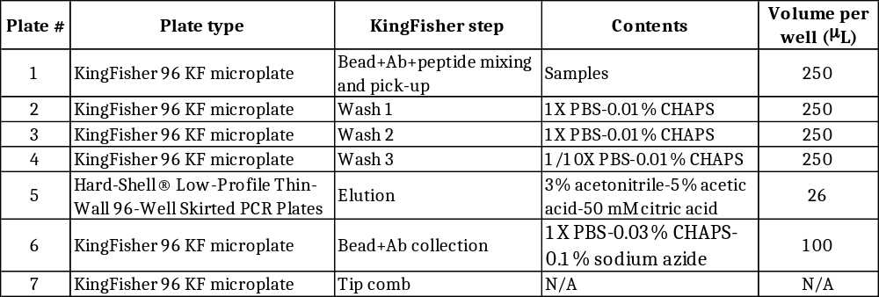

- The following shows the details of the KingFisher method employed for washing and eluting the samples. No precollection was employed at the beginning of any step, the samples were not heated during mixing, and no postmixing was employed at the end of any step. The method takes about 25 minutes. 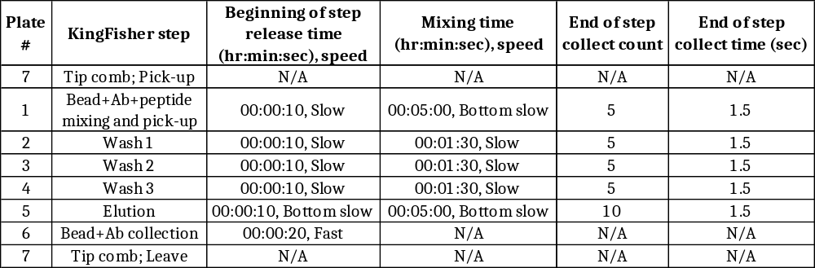

- At conclusion of the Kingfisher method, there are three plates that require further processing (Capture plate #1, Elution plate #5, Bead collection plate #6)
- Seal plate #1 (Capture plate) and store at 4°C.
- Seal plate #6 (Antibody-beads collection plate) and store at 4°C. Save collected beads.
- Cover the plate containing the eluates with ThermalSeal® PCR Sealing Film and spin the plate at 800 × g for 30 seconds.
- Place the elution plate on a plate magnet for 5 minutes.
- Transfer the eluates into a clean PCR plate for LC-MS analysis and seal with film.

Referenced Documents
None.

