STANDARD OPERATING PROCEDURE
Title: Peptide Immunoaffinity Enrichment
Version #: 2018 | Author: Paulovich Lab

Purpose
The purpose of this document is to describe the enrichment of targeted peptides using monoclonal antibodies.

Responsibilities
It is the responsibility of person(s) performing this procedure to be familiar with laboratory safety procedures. The interpretation of results must be done by a person trained in the procedure and familiar with such interpretation.

Materials and Reagents
- 1 M Tris (pH 8.0), (Sigma, T2694)
- Water, HPLC grade (Fisher, W5-1)
- Acetonitrile, HPLC grade (Fisher, A998-1)
- Formic Acid (EDM, 11670-1)
- 10 × PBS (ThermoFisher Scientific, BP39920)
- CHAPS (Thermo Scientific, 28300)
- Acetic Acid, ACS reagent, ≥99.7% (Sigma, 242853)
- Citric Acid (Fluka, Sigma, 94068)
- KingFisher Magnetic Particle Processor
- KingFisher, PCR 96 well head
- Labquake tube rotator or shaker
- DynaMagTM-96 Side Skirted Magnet (12027, Life Technologies)
- 200 µL 96 well plates (ThermoFisher Scientific, 97002540) ; used for captures and washes
- Hard-Shell® Low-Profile Thin-Wall 96-Well Skirted PCR Plates (BioRad, HSP-9601) ; used for elution plate
- Square Matrix CapMats For 2 mL blocks (ThermoFisher Scientific, 4421) ; a sealer for capture plates
- AdvantageTM Purple Framed 96 Square Well Pattern Teflon Sealing Film (Analytical, 961201) ; alternative sealer for capture plates
- ThermalSeal® PCR Sealing Film
- Chemically resistant sealing foil (BioExpress, T-3025-8B), or equivalent ; for freezer storage
- 96-well Silicone Sealing Mat (Axygen Scientific, 22-513), or equivalent ; for autosampler

Special Reagents
- Rabbit-anti-human monoclonal antibodies (mAbs) ustom-generated to the tryptic and proteotypic peptide targets and covalently coupled to magnetic Protein G beads.

Solutions
- 1 × PBS / 0.01% CHAPS. May be made in advance and stored at room temp.
  - 0.5 g CHAPS in 10mL LCMS-grade water.
  - Add 100 mL of 10 × PBS and 2 mL of 5% CHAPS to LCMS-grade water, final volume 1L.
- 0.1 × PBS / 0.01% CHAPS. May be made in advance and stored at room temp.
  - Add 10 mL of 10 × PBS and 2mL of 5% CHAPS to LCMS-grade water, final volume 1L.
- 5% acetic acid / 3% acetonitrile / 50 mM citrate:
  - Dissolve 8.4 g citric acid monohydrate in 200 mL of LCMS-grade water to make 200 mM citrate.
  - Mix 3.0 mL LCMS-grade acetonitrile, 5.0 mL acetic acid, 25 mL of 200 mM citrate, bring to 100 mL with water.

Procedure

- Resuspend the digested and desalted sample in 200 μL of 1 × PBS / 0.01% CHAPS using the 200 µL 96 well plates. If necessary, transfer the sample to the appropriate Capture Plate in the kit.
- Check that the pH is between 7.5 - 8.0. If necessary, adjust with 1 M Tris, pH 8.0 (5-10 µL should be sufficient).
- Mix the Antibody beads in the tube provided. Dispense enough beads to complete a capture plate into a separate tube. Add 24 µL of the Antibody beads multi-mix #1 (mAbs to phosphorylated peptide targets) to each sample well. When adding the beads, vortex the bead solution and pipet the master mix bead solution up and down several times to ensure well-mixed beads.
- Cover the plate with a Square Matrix CapMat (or Advantage Teflon Sealing Film). Align carefully and seal it by pressure to ensure that no liquid can leak from any of the wells.
- Incubate samples overnight at 4 °C with tumbling on a Labquake tube rotator or Lab Shaker.
- Remove samples from the tumbler and centrifuge at 800 × g for 30 seconds to remove liquid that may be on the mat surface. Then carefully remove the mat/seal.
- Wash the beads and elute the peptides (using KingFisher method).
- Wash the beads twice with 200 µL of 1 × PBS / 0.01% CHAPS and once with 200 µL of 0.1 × PBS / 0.01% CHAPS by mixing beads for 1.5 min in each wash solution. The peptides are eluted in PCR plates by mixing the beads for 5 min in 3% acetonitrile / 5% acetic acid / 50 mM citrate:

The following lists plate components and positions on the KingFisher (note elution volume and buffer may change):

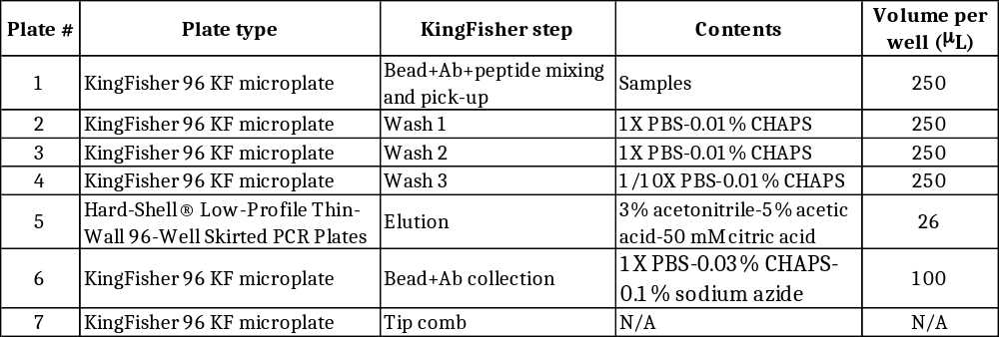

The following shows the details of the KingFisher method employed for washing and eluting the samples. No precollection was employed at the beginning of any step, the samples were not heated during mixing, and no postmixing was employed at the end of any step. The method takes about 25 minutes.

